**AISKEN CONSTRUCTION WEBSITE**

**A Mini Project Report submitted to**

**JAWAHARLAL NEHRU TECHNOLOGICAL UNIVERSITY ANANTAPUR.**

**In Patial Fulfillment of the Requirements for the Award of the degree of**

**BACHELOR OF TECHNOLOGY**

**IN**

**INFORMATION TECHNOLOGY**

|  |  |
| --- | --- |
| **G DEEPIKA** | **21121A3817** |
| **K SUSHMA**  **K BHAVANA**  **S ROHITH KUMAR**  **P VAMSI** | **21121A3819**  **21121A3822**  **21121A3835**  **22125A3803** |

*Submitted by*

*Under the Guidance of*

**Mr. P. Yogendra Prasad**

Assistant Professor



**Department of Information Technology**

SREE VIDYANIKETHAN ENGINEERING COLLEGE

(AUTONOMOUS)

Sree Sainath Nagar, Tirupati – 517 102

(2023-2024)

SREE VIDYANIKETHAN ENGINEERING COLLEGE

(AUTONOMOUS)

Sree Sainath Nagar, Tirupati

**DEPARTMENT OF INFORMATION TECHNOLOGY**

**CERTIFICATE**

This is to certify that the mini project report entitled

**“AISKEN CONSTRUCTION WEBSITE”**

is the Bonafide work done by

|  |  |
| --- | --- |
| **G DEEPIKA** | **21121A3817** |
| **K SUSHMA**  **K BHAVANA**  **S ROHITH KUMAR**  **P VAMSI** | **21121A3819**  **21121A3822**  **21121A3835**  **22125A3803** |

in the Department of **Information Technology** , and submitted to Jawaharlal Nehru Technological University Anantapur, Ananthapuramu in partial fulfilment of the requirements for the award of the degree of Bachelor of Technology in Information Technology during the academic year 2023-2024. This work has been carried out under my supervision. The results of this mini project work have not been submitted to any university for the award of degree or diploma.

***Guide: Head:***

Mr. P. Yogendra Prasad Dr. K. Ramani

Assistant Professor Professor & Head

Dept. of IT Dept. of IT

**INTERNAL EXAMINER EXTERNAL EXAMINER**

**DECLARATION**

We hereby declare that this project report titled **“MAPS & BAGS – A Travel Guide”** is a genuine work carried out by us, in **B.Tech *(Information Technology)*** degree course of **Jawaharlal Nehru Technological University Anantapur** and has not been submitted to any other course or University for the award of any degree by us.

We declare that this written submission represents our ideas in our own words and where others' ideas or words have been included, we have adequately cited and referenced the original sources. We also declare that we have adhered to all principles of academic honesty and integrity and have not misrepresented or fabricated or falsified any idea / data / fact / source in our submission. We understand that any violation of the above will cause for disciplinary action by the Institute and can also evoke penal action from the sources which have thus not been properly cited or from whom proper permission has not been taken when needed.

Signature of the students



**ABSTRACT**

The Construction Website project aims to create a user-friendly and visually engaging online platform using HTML, CSS, and JavaScript. This website serves as a digital hub for a construction company, showcasing its services, projects, and expertise to potential clients and visitors. The website's frontend development involves HTML for structuring the content, CSS for styling and layout design, and JavaScript for interactive elements and enhanced user experience. The layout prioritizes responsiveness, ensuring seamless access across various devices, including desktops, tablets, and smartphones. An inviting landing page introducing the company, highlighting its core services, and displaying recent projects through a visually appealing slideshow or gallery. Detailed information about the services offered, including construction, renovation, architectural design, etc., with engaging visuals and descriptive content. A dedicated section showcasing completed projects, including descriptions, images, and possibly client testimonials, allowing visitors to explore the company's expertise and capabilities. A contact form or contact details enabling visitors to reach out for inquiries, consultations, or project collaborations. Integration with Google Maps for easy location access might be considered. Ensuring the website adapts seamlessly to different screen sizes and devices, providing an optimal viewing experience. Implementing interactive elements using JavaScript to enhance user engagement, such as animated elements, dropdown menus, image sliders, or interactive forms. The development process involves utilizing HTML to structure the website's content, CSS for styling and layout, and JavaScript for interactive functionalities. The codebase will adhere to best practices, ensuring clean, well-commented, and maintainable code. Testing and optimization will be carried out to ensure cross-browser compatibility, responsiveness, and overall performance. Regular maintenance will be essential to keep the website up-to-date with evolving web standards and client requirements. The Construction Website project aims to create an aesthetically pleasing, informative, and functional online platform using HTML, CSS, and JavaScript to showcase the construction company's services and projects while providing an intuitive and engaging user experience for visitors.

***Keywords:*** User-friendly, responsive, HTML, JAVASCRIPT, PHP

i

**TABLE OF CONTENT**

|  |  |
| --- | --- |
| **Title** | **Page No.** |
| ABSTRACT | i |
| **CHAPTER 1: INTRODUCTION** | 2 |
| INTRODUCTION | 2 |
| STATEMENT OF THE PROBLEM | 3 |
| OBJECTIVES | 4 |
| LIMITATIONS | 4 |
| **CHAPTER 2: METHODOLOGY** | 5 |
| **CHAPTER 3: DESIGN** | 6 |
| REQUIREMENTS | 6 |
| SYSTEM DESIGN | 6 |
| TECHNOLOGIES USED | 7 |
| **CHAPTER 4: IMPLEMENTATION** | 8 |
| **CHAPTER: 5 PROPOSED SYSTEM ARCHITECTURE** | 9 |
| FLOW CHART | 10 |
| **CHAPTER 6: CODING AND RESULT** | 11 |
| CODE | 11 |
| RESULT | 101 |
| **CHAPTER 7: CONCLUSION AND FUTURE WORK** | 110 |
| CONCLUSION | 110 |
| FUTURE WORK | 110 |

**CHAPTER – 1**

**INTRODUCTION**

* 1. **Introduction:**

This report presents a description and analysis of construction, dedicated to delivering top-tier services and transformative projects. This website serves as your gateway to explore our comprehensive range of construction solutions, expertise, and a rich portfolio of successful endeavors.

Through the amalgamation of HTML, CSS, and JavaScript, we've meticulously designed a digital space that echoes our commitment to excellence. HTML structures the content with precision, ensuring a logical flow and effortless navigation. CSS lends its creative touch, crafting an aesthetically pleasing layout that adapts flawlessly to various devices and screen sizes. Meanwhile, JavaScript infuses interactivity, elevating your browsing experience and making it both engaging and intuitive.

Our website isn't merely a showcase; it's a testament to our passion for construction innovation. Here, you'll discover a collection of our finest projects, a detailed breakdown of our services, and a glimpse into the expertise that defines us.

Welcome to Construction Website, where innovation meets construction, and where every project reflects our unwavering dedication to building a better future.

* 1. **Problem Statement:**

The construction industry is highly competitive and demands a robust online presence to effectively showcase expertise, engage potential clients, and stand out among competitors. However, many construction firms face challenges in establishing an impactful digital footprint. The problem lies in the inadequacy of current construction websites to effectively represent the company's capabilities, engage visitors, and convert them into clients. There is a pressing need for a construction website that not only showcases the company's expertise but also provides an exceptional user experience, informative content, and effortless communication channels to bridge the gap between the company and its audience.

* 1. **Objective:**

The main objective of the Project is to give the users about the construction details, services and repairs provided. The objectives are:

* Centralize information
* Enhance accessibility
* Provide comprehensive details
* Provide services details
* Provide improvements and repairs details
* Ensure responsive design
  1. **Limitations:**
* Limited availability of comprehensive information.
* Overwhelming amount of options
* Lack of reliable and curated recommendations

**CHAPTER – 2**

**METHODOLOGY**

The development methodology for the construction webpage at Construction company involves a systematic approach aimed at creating a modern, user-centric, and impactful online platform. Beginning with comprehensive requirement analysis, we delve into stakeholder discussions to understand specific goals, target audience, and desired functionalities. Subsequently, extensive research and planning inform the site structure, content hierarchy, and user journey. Design and prototyping stages translate these insights into visual wireframes and mockups, allowing for iterative feedback before proceeding to frontend development. Leveraging HTML, CSS, and JavaScript, the frontend is built with a focus on responsiveness, sleek design elements, and interactive features. Content creation and integration follow suit, ensuring informative and engaging material aligns seamlessly within the site's framework. Rigorous testing for functionality, performance, and user experience precedes user feedback and adjustments, ensuring a user-friendly interface. Finally, deployment and post-launch monitoring sustain the site's relevance and performance through regular updates and maintenance, ensuring an enduring and impactful online presence for Construction company.

**CHAPTER – 3**

**SYSTEM DESIGN**

**3.1 Requirements:**

The user should have the appropriate version of windows.

* The system should have up to 1 GB ram minimum requirements for the application.
* Internet Connectivity is a must for this purpose.

**3.2 System Design:**

The website has a user-friendly and well-designed design to ensure a smooth browsing experience. The following sections describe the main content and structure of the site:

**3.3 Technologies used:**

The website is built using front-end technologies to create an engaging and dynamic user interface. The key technologies employed in the development of this website are:

**HTML5:** The website structure and content are created using HTML5, ensuring semantic markup and proper organization of information.

**CSS3:** CSS3 is used for styling and visual presentation of the website, including layout design, color schemes, topography, and responsive elements.

**JAVASCRIPT:** JavaScript is utilized to implement interactive features such as search functionality, user reviews, interactive booking, dynamic content loading.

**CHAPTER – 4**

**IMPLEMENTATION**

The implementation of the project consists of several stages to create a website for construction company in India. First, a good needs analysis was done to understand the purpose of the project, its target audience and the work that needs to be done. The analysis formed the basis for writing a comprehensive and updates of construction website, including services provided by company, repairs provided by the company and the chatbot is provided. After the content is collected, the wireframing and design phase of the website began. This includes clear layouts and designs to provide a clear user experience, design for consistency across devices, and creating beautiful connections. After this front-end development phase, which uses HTML5, CSS3, JavaScript, and php to implement the website’s visual content, interactive features, and user-interface. The collected data was organized in the database. The database will create a relationship between information organizations to enable the retrieval and display of information on the website. We performed quality testing and quality assurance to website functionality, functionality and browser compatibility.

**CHAPTER – 5**

**PROPOSED SYSTEM ARCHITECTURE**

The system architecture for the website showcasing construction fields follows a layered approach. At the presentation layer, the user interface is developed using technologies like HTML, CSS and JavaScript. The application layer handles the business logic and user requests. The data access layer interacts with the underlying database, performing data retrieval and storage using technologies like MYSQL. The proposed system architecture is designed to be modular, scalable, and maintainable, allowing for future enhancements and the addition of new features.

* 1. **Flow Chart:**

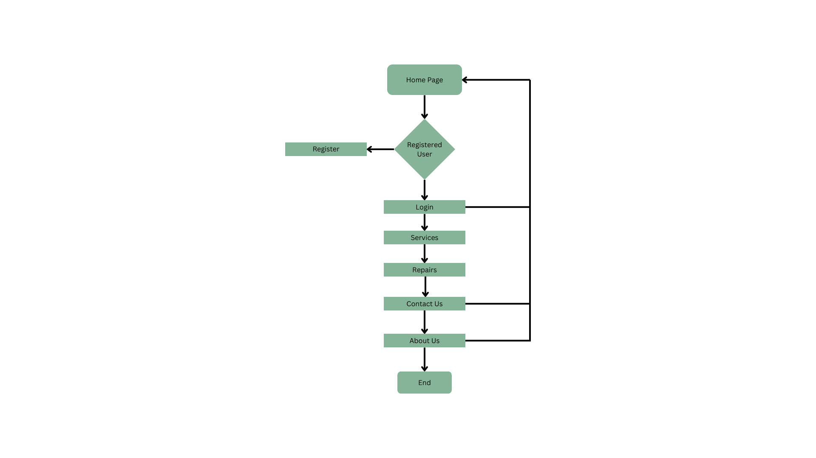

**Fig. Demonstration of the Website**

**CHAPTER – 6**

**CODING ANALYSIS AND RESULTS**

**6.1 Code:**

**i. Home Page:**

home.html:

<!DOCTYPE html>

<html lang="en">

<head>

<meta charset="UTF-8" />

<meta http-equiv="X-UA-Compatible" content="IE=edge" />

<meta name="viewport" content="width=device-width, initial-scale=1.0" />

<link rel="stylesheet" href="../css/style.css" />

<link rel="stylesheet" href="./style.css">

<title>AISKCON-Construction</title>

<link rel="icon" type="image/x-icon" href="./img/favicon_io/favicon.ico" />

</head>

<body>

<!-- Navbar Section Started -->

<nav class="navBar1">

<div class="fullNav">

<div id="logo">

<a href="index.html"><img src="../img/logo/navLogo.png" alt="AISKCON-Construction" /></a>

</div>

<ul class="list1">

<li id="home"><a href="../home">Home</a></li>

<li id="services">

<div>

<pre><a href="../ServiceSection">Services</a> <i class="fas fa-chevron-circle-down"></i></pre>

</div>

<div class="drop1">

<div class="empty"></div>

<div class="non-empty">

<ul>

<li>

<a href="../ServiceSection#interior-designing">Interior Designing</a>

</li>

<li>

<a href="../ServiceSection#construction-management">

Construction Management

</a>

</li>

<li>

<a href="../ServiceSection#consultancy-services">Consultancy Services</a>

</li>

<li>

<a href="../ServiceSection#environmental-service">Environmental Services</a>

</li>

<li>

<a href="../ServiceSection#retrofication">Retrofication</a>

</li>

<li>

<a href="../ServiceSection#destructive">Destructive & NDT Testing</a>

</li>

</ul>

</div>

</div>

</li>

<li id="repair">

<div>

<pre><a href="../repair">Repairs</a> <i class="fas fa-chevron-circle-down"></i></pre>

</div>

<div class="drop2">

<div class="empty"></div>

<div class="non-empty">

<ul>

<li><a href="../repair#home-repair">Home Repairs</a></li>

<li><a href="../repair#kitchen-repair">Kitchen Repairs</a></li>

<li>

<a href="../repair#bathroom-repair">Bathroom Repair</a>

</li>

<li>

<a href="../repair#furniture-repair">Furniture Repair</a>

</li>

<li><a href="../repair#plumbing">Plumbing & Pipes</a></li>

</ul>

</div>

</div>

</li>

<li><a href="../aboutUs">About</a></li>

<li><a href="../contact">Contact</a></li>

<li></li>

</ul>

<div id="bt2">

<button><i class="fa-solid fa-bars"></i></button>

</div>

</div>

</nav>

<!-- Navbar Section Finished -->

<!--home page start-->

<div class="homepage">

<div class="bookus-section">

<h1 class="bookus-section-heading">Transforming</h1>

<h1 class="bookus-section-heading">The Built</h1>

<h1 class="bookus-section-heading">World</h1>

<p class="bookus-section-quot">

"Quality is never an accident. It is always the result of intelligence effort." - John Ruskin

</p>

<button class="bookus-section-button">Book Us</button>

</div>

<div class="bookus-image-container">

<img src="../img/vectors/hero.gif" alt="construction" class="construction-image">

</div>

</div>

<!--home page end-->

<h1 class="OUR-services">OUR SERVICES</h1>

<!--our services section start-->

<div class="our-services-section" data-aos="fade-up" data-aos-easing="ease" data-aos-duration="500">

<div class="construction-section">

<img src="../img/bg/generalconstruction.webp" alt="general construction" class="image">

<h3 class="construction-heading">General Constructing</h3>

<p class="construction-detail">

Construction work encompasses the creation and upkeep of structures such as buildings, roads, bridges, and tunnels.

</p>

</div>

<div class="construction-section">

<img src="../img/bg/constructionmanagement.webp" alt="general construction" class="image">

<h3 class="construction-heading">Construction Management</h3>

<p class="construction-detail">

Construction work encompasses the creation and upkeep of structures such as buildings, roads, bridges, and tunnels.

</p>

</div>

<div class="construction-section">

<img src="../img/bg/design-and-build.webp" alt="general construction" class="image">

<h3 class="construction-heading">Design and Build</h3>

<p class="construction-detail">

Construction work encompasses the creation and upkeep of structures such as buildings, roads, bridges, and tunnels.

</p>

</div>

<div class="construction-section">

<img src="../img/bg/preconstruction.webp" alt="general construction" class="image">

<h3 class="construction-heading">Preconstruction Consulting</h3>

<p class="construction-detail">

Construction work encompasses the creation and upkeep of structures such as buildings, roads, bridges, and tunnels.

</p>

</div>

<div class="construction-section">

<img src="../img/bg/special-projects.webp" alt="general construction" class="image">

<h3 class="construction-heading">Special Projects</h3>

<p class="construction-detail">

Construction work encompasses the creation and upkeep of structures such as buildings, roads, bridges, and tunnels.

</p>

</div>

<div class="construction-section">

<img src="../img/bg/renovation.webp" alt="general construction" class="image">

<h3 class="construction-heading">Renovations</h3>

<p class="construction-detail">

Construction work encompasses the creation and upkeep of structures such as buildings, roads, bridges, and tunnels.

</p>

</div>

</div>

<!--our services section end-->

<!--details container start-->

<div class="details-container" data-aos="fade-up" data-aos-easing="ease" data-aos-duration="500">

<div class="card-container">

<i class="fa fa-compass"></i>

<h1 class="detail-head">Vastu</h1>

<p class="detail-name">Consultancy</p>

</div>

<div class="card-container">

<i class="fa fa-vr-cardboard"></i>

<h1 class="detail-head">3D</h1>

<p class="detail-name">Modeling</p>

</div>

<div class="card-container">

<i class="fa fa-city"></i>

<h1 class="detail-head">Project</h1>

<p class="detail-name">Planning</p>

</div>

<div class="card-container">

<i class="fa fa-envira"></i>

<h1 class="detail-head">Green</h1>

<p class="detail-name">Designs</p>

</div>

</div>

<!--contact with our experts start-->

<section id="contactWithOurExperts">

<div class="contact-with-our-experts-container">

<img src="../img/vectors/customer1.png" alt="herologo" class="herologo" data-aos="fade-up" data-aos-easing="ease" data-aos-duration="500">

<div class="contact-container" data-aos="fade-up" data-aos-easing="ease" data-aos-duration="500">

<h1 class="contact-heading">Contact With Our Experts</h1>

<p class="contact-para">Book your appointment to talk to our experts who will assist you with all your doubts regarding our services.</p>

<div class="contact-button-container">

<button class="contact-button">

<i class="fa fa-phone"></i> Contact

</button>

<button class="contact-button">

<i class="fa fa-calendar"></i> Book us

</button>

</div>

</div>

</div>

</section>

<!--contact with our experts end-->

<!-- FAQ starts -->

<section class="faq">

<div class="faq-heading">

<h1>FAQs</h1>

</div>

<div class="faq-content">

<div class="faq-block" data-aos="fade-up" data-aos-easing="ease" data-aos-duration="500">

<div class="faq-question">

<h2>1. Why do I need an interior designer?</h2>

<i class="fa-solid fa-plus fa-xl"></i>

</div>

<div class="faq-answer">

<p>

You can think of an interior designer as a film director. Their

job is to monitor every minute detail from start to the final cut.

From pre-production to the final edit, their perspective is

responsible for shaping the final product. Similarly, interior

designers are professionals who are able to gauge your needs and

tastes to deliver your dream home. They assist you in getting

custom-designed pieces that fit perfectly into your beautiful

vision. From raw materials to finished products, they take care of

everything!

</p>

</div>

</div>

<div class="faq-block" data-aos="fade-up" data-aos-easing="ease" data-aos-duration="1000">

<div class="faq-question">

<h2>2. Why is Aiskcon perfect for your design?</h2>

<i class="fa-solid fa-plus fa-xl"></i>

</div>

<div class="faq-answer">

<p>

Aiskcon is the perfect partner who can build your home interiors

just the way you want! Our design experts customize designs as per

your needs. They will listen to your ideas and suggest options. At

Aiskcon, we incorporate advanced technology into our modular

solutions to create flawless interiors and also to expedite the

process of making your dream home a reality. So, book your

consultation today with India's Most Trusted Home Interiors Brand,

Aiskcon and talk to our designers about your project.

</p>

</div>

</div>

<div class="faq-block" data-aos="fade-up" data-aos-easing="ease" data-aos-duration="1500">

<div class="faq-question">

<h2>3. What services are included under home interior design?</h2>

<i class="fa-solid fa-plus fa-xl"></i>

</div>

<div class="faq-answer">

<p>

Home interior design services typically include a wide range of

design and decor-related tasks that are aimed at improving the

functionality and aesthetics of a home's interior space. Some of

the most common services that are included under home interior

design are:

<br />

1. Space Planning <br />

2. Colour Selection <br />

3. Material Selection <br />

4. Lighting Design <br />

5. Furniture Selection <br />

6. Decorative Accessories

</p>

</div>

</div>

<div class="faq-block" data-aos="fade-up" data-aos-easing="ease" data-aos-duration="2000">

<div class="faq-question">

<h2>4. What will be the timelines for my project completion?</h2>

<i class="fa-solid fa-plus fa-xl"></i>

</div>

<div class="faq-answer">

<p>

The timeline for a construction project completion can vary

depending on a number of factors, such as the size and complexity

of the project, the location, weather conditions, availability of

materials, etc. Here in Aiskcon we deliver the project efficiently

and on earliest possible time

</p>

</div>

</div>

<div class="faq-block" data-aos="fade-up" data-aos-easing="ease" data-aos-duration="2500">

<div class="faq-question">

<h2>6. What are the trending interior design styles?</h2>

<i class="fa-solid fa-plus fa-xl"></i>

</div>

<div class="faq-answer">

<p>

1. Minimalism <br />

2. Biophilic design <br />

3. Industrial design <br />

4. Scandinavian design <br />

5. Bohemian design <br />

6. Modern farmhouse <br />

7. Art Deco <br />

</p>

</div>

</div>

</div>

</section>

<!-- FAQ end -->

<!-- Hire Us Section Start -->

<section class="hireus">

<div class="hireus-box" data-aos="fade-up" data-aos-easing="ease" data-aos-duration="1000">

<div class="hireus-content">

<h1>Transform your living space into a work of Art!</h1>

<button onclick="window.location.href='./slotBooking/form.html'">

<span> Hire us</span>

</button>

</div>

</div>

</section>

<!-- Hire Us Section End -->

<a class="gotop" href="#"><i class="fa-solid fa-arrow-up fa-lg"></i></a>

<!-- chatbot start -->

<button type="button" aria-label="Open chatbot" class="chatbot-btn">

<i class="fa-regular fa-comment " style="font-size: 1.5rem;"></i>

</button>

<div class="chat-container">

<div class="chat-header">

<h2>Chat with us</h2>

</div>

<div class="chat-body"></div>

<form class="chat-form" novalidate>

<input type="text" id="chat-input" class="chat-input" name="Chat" aria-label="Enter your message here" autofocus>

<button type="submit" aria-label="Send message" class="chatform-btn" disabled>

<i class="fa-regular fa-paper-plane"></i>

</button>

</form>

</div>

<!-- chatbot end -->

<!-- Footer Section Started -->

<footer class="footer">

<div class="container">

<div class="row">

<div class="footer-col footer-brand">

<div class="footer-logo">

<img src="../img/logo/aiskcon logo.png" alt="logo" srcset="" />

</div>

<div class="social-links">

<a href="#"><i class="fab fa-facebook-f"></i></a>

<a href="#"><i class="fab fa-twitter"></i></a>

<a href="#"><i class="fab fa-instagram"></i></a>

<a href="#"><i class="fab fa-linkedin-in"></i></a>

<a href="#"><i class="fab fa-github"></i></a>

</div>

</div>

<div class="footer-col service">

<h4>Services</h4>

<ul>

<li>

<a href="./ServiceSection#interior-designing"><i class="fa-solid fa-angle-right"></i> Interior

Designing</a>

</li>

<li>

<a href="./ServiceSection#construction-management"><i class="fa-solid fa-angle-right"></i> Construction

Management</a>

</li>

<li>

<a href="./ServiceSection#consultancy-services"><i class="fa-solid fa-angle-right"></i> Consultancy

Services</a>

</li>

<li>

<a href="./ServiceSection#environmental-service"><i class="fa-solid fa-angle-right"></i> Environmental

Services</a>

</li>

<li>

<a href="./ServiceSection#retrofication"><i class="fa-solid fa-angle-right"></i> Retrofication</a>

</li>

<li>

<a href="./ServiceSection#destructive"><i class="fa-solid fa-angle-right"></i> Destructive & NDT

Testing</a>

</li>

</ul>

</div>

<div class="footer-col repair">

<h4>Repairs</h4>

<ul>

<li>

<a href="./repair#home-repair"><i class="fa-solid fa-angle-right"></i> Home Repairs</a>

</li>

<li>

<a href="./repair#kitchen-repair"><i class="fa-solid fa-angle-right"></i> Kitchen Repairs</a>

</li>

<li>

<a href="./repair#bathroom-repair"><i class="fa-solid fa-angle-right"></i> Bathroom Repair</a>

</li>

<li>

<a href="./repair#furniture-repair"><i class="fa-solid fa-angle-right"></i> Furniture Repair</a>

</li>

<li>

<a href="./repair#plumbing"><i class="fa-solid fa-angle-right"></i> Plumbing & Pipes</a>

</li>

</ul>

</div>

<div class="footer-col contact">

<h4>Contact</h4>

<ul>

<li>

<a href="mailto:aiskconofficial@gmail.com"><i class="fa-solid fa-envelope"></i>

aiskconofficial@gmail.com</a>

</li>

<li>

<a href="tel:+917993421081"><i class="fa-solid fa-phone"></i> +91-7993421081</a>

</li>

<li>

<a href="tel:+919010286990"><i class="fa-solid fa-phone"></i> +91-9010286990</a>

</li>

<li>

<a href="tel:+918699048327"><i class="fa-solid fa-phone"></i> +91-9699048327</a>

</li>

<li>

<a href="tel:+916302449292"><i class="fa-solid fa-phone"></i> +91-6302449292</a>

</li>

<li>

<a href="tel:+917981816514"><i class="fa-solid fa-phone"></i> +91-7981816514</a>

</li>

</ul>

</div>

</div>

<hr style="margin: 0 auto; width: 90%; margin-top: 10px" />

<div>

<div class="footer-copyright"></div>

</div>

</div>

</footer>

<!-- Footer Section Finished -->

<script src="https://cdn.jsdelivr.net/particles.js/2.0.0/particles.min.js"></script>

<script src="https://threejs.org/examples/js/libs/stats.min.js"></script>

<script src="https://unpkg.com/aos@2.3.1/dist/aos.js"></script>

<script>

AOS.init();

</script>

<script src="../js/main.js"></script>

</body>

</html>

Home.css:

.homepage{

margin:20px;

height:100%;

display:flex;

flex-direction:row;

}

.bookus-section{

height:100%;

width:50vw;

display:flex;

flex-direction:column;

justify-content:center;

align-items: flex-start;

padding:30px;

}

.bookus-section-heading{

color:blue;

font-size:48px;

font-weight:bold;

}

.bookus-section-quot{

padding-top:20px;

font-size:18px;

}

.bookus-section-button{

margin-top:20px;

height:7vh;

width:18vh;

background-image:linear-gradient(to right,blue,darkblue);

color:white;

border:0px;

border-radius:4px;

font-size:16px;

}

.bookus-section-button:hover{

background-image:linear-gradient(to right,darkblue,blue);

cursor:pointer;

}

.bookus-image-container{

height:100%;

width:50vw;

display:flex;

justify-content: flex-start;

align-items: flex-start;

}

.construction-image{

height:50vh;

width:50vw;

}

.OUR-services{

text-align:center;

font-weight:bold;

font-size:36px;

}

.our-services-section{

height:100%;

display:flex;

flex-direction:column;

margin:30px;

}

.construction-section{

height:100%;

margin:20px;

display:flex;

flex-direction:column;

justify-content: center;

align-items: flex-start;

}

.image{

height:30vh;

width:100%;

border-radius:10px;

object-fit: cover;

transition: all 0.3s ease;

}

.image:hover{

transform: scale(1.1);

opacity: 1;

}

.construction-heading{

font-size:20px;

font-weight:bold;

padding-top:20px;

}

.construction-detail{

font-size:16px;

opacity:0.8;

padding-top:20px;

}

.contact-with-our-experts-container{

height:100%;

width:100%;

display:flex;

flex-direction:column;

justify-content:center;

align-items:center;

margin:20px;

}

.contact-container{

text-align:center;

height:100%;

width:80vw;

display:flex;

flex-direction:column;

justify-content:center;

align-items:center;

}

.contact-heading{

font-size:36px;

}

.contact-para{

font-size:18px;

}

.contact-button-container{

padding-top:40px;

}

.fa{

color:white;

}

.contact-button{

background-image:linear-gradient(to right,blue,darkblue);

height:8vh;

width:26vh;

border:0px;

border-radius:8px;

color:white;

font-size:18px;

margin-right:20px;

}

.contact-button:hover{

background-image:linear-gradient(to right,darkblue, blue);

}

.details-container{

height:100%;

margin:30px;

display:flex;

flex-direction:row;

justify-content:center;

align-items:center;

flex-wrap:wrap;

}

.card-container{

height:36vh;

width:36vw;

display:flex;

flex-direction:column;

justify-content: center;

align-items: center;

border: 1px solid gray;

border-radius:8px;

box-shadow: 2px 2px 2px gray;

transition: all 0.3s ease;

margin:20px;

}

.card-container:hover{

transform: scale(1.1);

opacity: 1;

}

.detail-head{

color:blue;

font-size:36px;

}

**ii. Login Page:**

login.html:

<!DOCTYPE html>

<html lang="en">

<head>

<meta charset="UTF-8">

<meta name="viewport" content="width=device-width, initial-scale=1.0">

<link rel='stylesheet' href='https://cdnjs.cloudflare.com/ajax/libs/twitter-bootstrap/4.5.0/css/bootstrap.min.css'>

<link rel='stylesheet' href='https://unicons.iconscout.com/release/v2.1.9/css/unicons.css'>

<link rel="stylesheet" href="./style.css">

<title>Document</title>

</head>

<body>

<div class="section">

<div class="container">

<div class="row full-height justify-content-center">

<div class="col-12 text-center align-self-center py-5">

<div class="section pb-5 pt-5 pt-sm-2 text-center">

<h6 class="mb-0 pb-3"><span>Log In </span><span>Sign Up</span></h6>

<input class="checkbox" type="checkbox" id="reg-log" name="reg-log"/>

<label for="reg-log"></label>

<div class="card-3d-wrap mx-auto">

<div class="card-3d-wrapper">

<div class="card-front">

<div class="center-wrap">

<div class="section text-center">

<h4 class="mb-4 pb-3">Log In</h4>

<div class="form-group">

<input type="email" name="logemail" class="form-style" placeholder="Your Email" id="logemail" autocomplete="off">

<i class="input-icon uil uil-at"></i>

</div>

<div class="form-group mt-2">

<input type="password" name="logpass" class="form-style" placeholder="Your Password" id="logpass" autocomplete="off">

<i class="input-icon uil uil-lock-alt"></i>

</div>

<a href="../home/index.html" class="btn mt-4">submit</a>

<p class="mb-0 mt-4 text-center"><a href="#" class="link">Forgot your password?</a></p>

</div>

</div>

</div>

<div class="card-back">

<div class="center-wrap">

<div class="section text-center">

<h4 class="mb-4 pb-3">Sign Up</h4>

<div class="form-group">

<input type="text" name="logname" class="form-style" placeholder="Your Full Name" id="logname" autocomplete="off">

<i class="input-icon uil uil-user"></i>

</div>

<div class="form-group mt-2">

<input type="email" name="logemail" class="form-style" placeholder="Your Email" id="logemail" autocomplete="off">

<i class="input-icon uil uil-at"></i>

</div>

<div class="form-group mt-2">

<input type="password" name="logpass" class="form-style" placeholder="Your Password" id="logpass" autocomplete="off">

<i class="input-icon uil uil-lock-alt"></i>

</div>

<a href="#" class="btn mt-4">submit</a>

</div>

</div>

</div>

</div>

</div>

</div>

</div>

</div>

</div>

</div>

</body>

</html>

Login.css:

body{

font-family: 'Poppins', sans-serif;

font-weight: 300;

font-size: 15px;

line-height: 1.7;

color: #c4c3ca;

background-color: #1f2029;

overflow-x: hidden;

}

a {

cursor: pointer;

transition: all 200ms linear;

}

a:hover {

text-decoration: none;

}

.link {

color: #c4c3ca;

}

.link:hover {

color: #ffeba7;

}

p {

font-weight: 500;

font-size: 14px;

line-height: 1.7;

}

h4 {

font-weight: 600;

}

h6 span{

padding: 0 20px;

text-transform: uppercase;

font-weight: 700;

}

.section{

position: relative;

width: 100%;

display: block;

}

.full-height{

min-height: 100vh;

}

[type="checkbox"]:checked,

[type="checkbox"]:not(:checked){

position: absolute;

left: -9999px;

}

.checkbox:checked + label,

.checkbox:not(:checked) + label{

position: relative;

display: block;

text-align: center;

width: 60px;

height: 16px;

border-radius: 8px;

padding: 0;

margin: 10px auto;

cursor: pointer;

background-color: #ffeba7;

}

.checkbox:checked + label:before,

.checkbox:not(:checked) + label:before{

position: absolute;

display: block;

width: 36px;

height: 36px;

border-radius: 50%;

color: #ffeba7;

background-color: #102770;

font-family: 'unicons';

content: '\eb4f';

z-index: 20;

top: -10px;

left: -10px;

line-height: 36px;

text-align: center;

font-size: 24px;

transition: all 0.5s ease;

}

.checkbox:checked + label:before {

transform: translateX(44px) rotate(-270deg);

}

.card-3d-wrap {

position: relative;

width: 440px;

max-width: 100%;

height: 400px;

-webkit-transform-style: preserve-3d;

transform-style: preserve-3d;

perspective: 800px;

margin-top: 60px;

}

.card-3d-wrapper {

width: 100%;

height: 100%;

position:absolute;

top: 0;

left: 0;

-webkit-transform-style: preserve-3d;

transform-style: preserve-3d;

transition: all 600ms ease-out;

}

.card-front, .card-back {

width: 100%;

height: 100%;

background-color: #2a2b38;

background-image: url('https://s3-us-west-2.amazonaws.com/s.cdpn.io/1462889/pat.svg');

background-position: bottom center;

background-repeat: no-repeat;

background-size: 300%;

position: absolute;

border-radius: 6px;

left: 0;

top: 0;

}

.card-back {

transform: rotateY(180deg);

}

.checkbox:checked ~ .card-3d-wrap .card-3d-wrapper {

transform: rotateY(180deg);

}

.center-wrap{

position: absolute;

width: 100%;

padding: 0 35px;

top: 50%;

left: 0;

transform: translate3d(0, -50%, 35px) perspective(100px);

z-index: 20;

display: block;

}

.form-group{

position: relative;

display: block;

margin: 0;

padding: 0;

}

.form-style {

padding: 13px 20px;

padding-left: 55px;

height: 48px;

width: 100%;

font-weight: 500;

border-radius: 4px;

font-size: 14px;

line-height: 22px;

letter-spacing: 0.5px;

outline: none;

color: #c4c3ca;

background-color: #1f2029;

border: none;

-webkit-transition: all 200ms linear;

transition: all 200ms linear;

box-shadow: 0 4px 8px 0 rgba(21,21,21,.2);

}

.form-style:focus,

.form-style:active {

border: none;

outline: none;

box-shadow: 0 4px 8px 0 rgba(21,21,21,.2);

}

.input-icon {

position: absolute;

top: 0;

left: 18px;

height: 48px;

font-size: 24px;

line-height: 48px;

text-align: left;

color: #ffeba7;

-webkit-transition: all 200ms linear;

transition: all 200ms linear;

}

.form-group input:-ms-input-placeholder {

color: #c4c3ca;

opacity: 0.7;

-webkit-transition: all 200ms linear;

transition: all 200ms linear;

}

.form-group input::-moz-placeholder {

color: #c4c3ca;

opacity: 0.7;

-webkit-transition: all 200ms linear;

transition: all 200ms linear;

}

.form-group input:-moz-placeholder {

color: #c4c3ca;

opacity: 0.7;

-webkit-transition: all 200ms linear;

transition: all 200ms linear;

}

.form-group input::-webkit-input-placeholder {

color: #c4c3ca;

opacity: 0.7;

-webkit-transition: all 200ms linear;

transition: all 200ms linear;

}

.form-group input:focus:-ms-input-placeholder {

opacity: 0;

-webkit-transition: all 200ms linear;

transition: all 200ms linear;

}

.form-group input:focus::-moz-placeholder {

opacity: 0;

-webkit-transition: all 200ms linear;

transition: all 200ms linear;

}

.form-group input:focus:-moz-placeholder {

opacity: 0;

-webkit-transition: all 200ms linear;

transition: all 200ms linear;

}

.form-group input:focus::-webkit-input-placeholder {

opacity: 0;

-webkit-transition: all 200ms linear;

transition: all 200ms linear;

}

.btn{

border-radius: 4px;

height: 44px;

font-size: 13px;

font-weight: 600;

text-transform: uppercase;

-webkit-transition : all 200ms linear;

transition: all 200ms linear;

padding: 0 30px;

letter-spacing: 1px;

display: -webkit-inline-flex;

display: -ms-inline-flexbox;

display: inline-flex;

background-color: #ffeba7;

color: #102770;

box-shadow: 0 8px 24px 0 rgba(255,235,167,.2);

}

.btn:active,

.btn:focus{

background-color: #102770;

color: #ffeba7;

box-shadow: 0 8px 24px 0 rgba(16,39,112,.2);

}

.btn:hover{

background-color: #102770;

color: #ffeba7;

box-shadow: 0 8px 24px 0 rgba(16,39,112,.2);

}

.logo {

position: absolute;

top: 30px;

right: 30px;

display: block;

z-index: 100;

transition: all 250ms linear;

}

.logo img {

height: 26px;

width: auto;

display: block;

}

**iii. SignUp Page:**

signup.html:

<!DOCTYPE html>

<html lang="en" >

<head>

<meta charset="UTF-8">

<title>Log In / Sign Up</title>

<link rel='stylesheet' href='https://unicons.iconscout.com/release/v2.1.9/css/unicons.css'>

<link rel="stylesheet" href="./style.css">

</head>

<body>

<!-- partial:index.partial.html -->

<div class="section">

<div class="container">

<div class="row full-height justify-content-center">

<div class="col-12 text-center align-self-center py-5">

<div class="section pb-5 pt-5 pt-sm-2 text-center">

<h6 class="mb-0 pb-3"><span>Log In </span><span>Sign Up</span></h6>

<input class="checkbox" type="checkbox" id="reg-log" name="reg-log"/>

<label for="reg-log"></label>

<div class="card-3d-wrap mx-auto">

<div class="card-3d-wrapper">

<div class="card-front">

<div class="center-wrap">

<div class="section text-center">

<h4 class="mb-4 pb-3">Log In</h4>

<div class="form-group">

<input type="email" name="logemail" class="form-style" placeholder="Your Email" id="logemail" autocomplete="off">

<i class="input-icon uil uil-at"></i>

</div>

<div class="form-group mt-2">

<input type="password" name="logpass" class="form-style" placeholder="Your Password" id="logpass" autocomplete="off">

<i class="input-icon uil uil-lock-alt"></i>

</div>

<a href="../login/index.html" class="btn mt-4">submit</a>

<p class="mb-0 mt-4 text-center"><a href="#0" class="link">Forgot your password?</a></p>

</div>

</div>

</div>

<div class="card-back">

<div class="center-wrap">

<div class="section text-center">

<h4 class="mb-4 pb-3">Sign Up</h4>

<div class="form-group">

<input type="text" name="logname" class="form-style" placeholder="Your Full Name" id="logname" autocomplete="off">

<i class="input-icon uil uil-user"></i>

</div>

<div class="form-group mt-2">

<input type="email" name="logemail" class="form-style" placeholder="Your Email" id="logemail" autocomplete="off">

<i class="input-icon uil uil-at"></i>

</div>

<div class="form-group mt-2">

<input type="password" name="logpass" class="form-style" placeholder="Your Password" id="logpass" autocomplete="off">

<i class="input-icon uil uil-lock-alt"></i>

</div>

<a href="../login/index.html" class="btn mt-4">submit</a>

</div>

</div>

</div>

</div>

</div>

</div>

</div>

</div>

</div>

</div>

<!-- partial -->

<script>

function signupValidation() { var valid = true;

$("#username").removeClass("error-field");

$("#email").removeClass("error-field");

$("#password").removeClass("error-field");

$("#confirm-password").removeClass("error-field"); var UserName = $("#username").val();

var email = $("#email").val();

var Password = $('#signup-password').val();

var ConfirmPassword = $('#confirm-password').val();

var emailRegex = /^[a-zA-Z0-9.!#$%&'*+/=?^_`{|}~-]+@[a-zA-Z0-9](?:[a-zA-Z0-9-

]{0,61}[a-zA-Z0-9])?(?:\.[a-zA-Z0-9](?:[a-zA-Z0-9-]{0,61}[a-zA-Z0-9])?)*$/;

$("#username-info").html("").hide();

$("#email-info").html("").hide(); if (UserName.trim() == "") {

$("#username-info").html("required.").css("color", "#ee0000").show();

$("#username").addClass("error-field"); valid = false;

}

if (email == "") {

$("#email-info").html("required").css("color", "#ee0000").show();

$("#email").addClass("error-field"); valid = false;

} else if (email.trim() == "") {

$("#email-info").html("Invalid email address.").css("color", "#ee0000").show();

$("#email").addClass("error-field"); valid = false;

} else if (!emailRegex.test(email)) {

$("#email-info").html("Invalid email address.").css("color", "#ee0000")

.show();

$("#email").addClass("error-field"); valid = false;

}

if (Password.trim() == "") {

$("#signup-password-info").html("required.").css("color", "#ee0000").show();

$("#signup-password").addClass("error-field"); valid = false;

}

if (ConfirmPassword.trim() == "") {

$("#confirm-password-info").html("required.").css("color", "#ee0000").show();

$("#confirm-password").addClass("error-field"); valid = false;

}

if(Password != ConfirmPassword){

$("#error-msg").html("Both passwords must be same.").show(); valid=false;

}

if (valid == false) {

$('.error-field').first().focus(); valid = false;

}

return valid;

}

</script>

</body>

</html>

Signup.css:

body{

font-family: 'Poppins', sans-serif;

font-weight: 300;

font-size: 15px;

line-height: 1.7;

color: #c4c3ca;

background-color: #1f2029;

overflow-x: hidden;

}

a {

cursor: pointer;

transition: all 200ms linear;

}

a:hover {

text-decoration: none;

}

.link {

color: #c4c3ca;

}

.link:hover {

color: #ffeba7;

}

p {

font-weight: 500;

font-size: 14px;

line-height: 1.7;

}

h4 {

font-weight: 600;

}

h6 span{

padding: 0 20px;

text-transform: uppercase;

font-weight: 700;

}

.section{

position: relative;

width: 100%;

display: block;

}

.full-height{

min-height: 100vh;

}

[type="checkbox"]:checked,

[type="checkbox"]:not(:checked){

position: absolute;

left: -9999px;

}

.checkbox:checked + label,

.checkbox:not(:checked) + label{

position: relative;

display: block;

text-align: center;

width: 60px;

height: 16px;

border-radius: 8px;

padding: 0;

margin: 10px auto;

cursor: pointer;

background-color: #ffeba7;

}

.checkbox:checked + label:before,

.checkbox:not(:checked) + label:before{

position: absolute;

display: block;

width: 36px;

height: 36px;

border-radius: 50%;

color: #ffeba7;

background-color: #102770;

font-family: 'unicons';

content: '\eb4f';

z-index: 20;

top: -10px;

left: -10px;

line-height: 36px;

text-align: center;

font-size: 24px;

transition: all 0.5s ease;

}

.checkbox:checked + label:before {

transform: translateX(44px) rotate(-270deg);

}

.card-3d-wrap {

position: relative;

width: 440px;

max-width: 100%;

height: 400px;

-webkit-transform-style: preserve-3d;

transform-style: preserve-3d;

perspective: 800px;

margin-top: 60px;

}

.card-3d-wrapper {

width: 100%;

height: 100%;

position:absolute;

top: 0;

left: 0;

-webkit-transform-style: preserve-3d;

transform-style: preserve-3d;

transition: all 600ms ease-out;

}

.card-front, .card-back {

width: 100%;

height: 100%;

background-color: #2a2b38;

background-image: url('https://s3-us-west-2.amazonaws.com/s.cdpn.io/1462889/pat.svg');

background-position: bottom center;

background-repeat: no-repeat;

background-size: 300%;

position: absolute;

border-radius: 6px;

left: 0;

top: 0;

}

.card-back {

transform: rotateY(180deg);

}

.checkbox:checked ~ .card-3d-wrap .card-3d-wrapper {

transform: rotateY(180deg);

}

.center-wrap{

position: absolute;

width: 100%;

padding: 0 35px;

top: 50%;

left: 0;

transform: translate3d(0, -50%, 35px) perspective(100px);

z-index: 20;

display: block;

}

.form-group{

position: relative;

display: block;

margin: 0;

padding: 0;

}

.form-style {

padding: 13px 20px;

padding-left: 55px;

height: 48px;

width: 100%;

font-weight: 500;

border-radius: 4px;

font-size: 14px;

line-height: 22px;

letter-spacing: 0.5px;

outline: none;

color: #c4c3ca;

background-color: #1f2029;

border: none;

-webkit-transition: all 200ms linear;

transition: all 200ms linear;

box-shadow: 0 4px 8px 0 rgba(21,21,21,.2);

}

.form-style:focus,

.form-style:active {

border: none;

outline: none;

box-shadow: 0 4px 8px 0 rgba(21,21,21,.2);

}

.input-icon {

position: absolute;

top: 0;

left: 18px;

height: 48px;

font-size: 24px;

line-height: 48px;

text-align: left;

color: #ffeba7;

-webkit-transition: all 200ms linear;

transition: all 200ms linear;

}

.form-group input:-ms-input-placeholder {

color: #c4c3ca;

opacity: 0.7;

-webkit-transition: all 200ms linear;

transition: all 200ms linear;

}

.form-group input::-moz-placeholder {

color: #c4c3ca;

opacity: 0.7;

-webkit-transition: all 200ms linear;

transition: all 200ms linear;

}

.form-group input:-moz-placeholder {

color: #c4c3ca;

opacity: 0.7;

-webkit-transition: all 200ms linear;

transition: all 200ms linear;

}

.form-group input::-webkit-input-placeholder {

color: #c4c3ca;

opacity: 0.7;

-webkit-transition: all 200ms linear;

transition: all 200ms linear;

}

.form-group input:focus:-ms-input-placeholder {

opacity: 0;

-webkit-transition: all 200ms linear;

transition: all 200ms linear;

}

.form-group input:focus::-moz-placeholder {

opacity: 0;

-webkit-transition: all 200ms linear;

transition: all 200ms linear;

}

.form-group input:focus:-moz-placeholder {

opacity: 0;

-webkit-transition: all 200ms linear;

transition: all 200ms linear;

}

.form-group input:focus::-webkit-input-placeholder {

opacity: 0;

-webkit-transition: all 200ms linear;

transition: all 200ms linear;

}

.btn{

border-radius: 4px;

height: 44px;

font-size: 13px;

font-weight: 600;

text-transform: uppercase;

-webkit-transition : all 200ms linear;

transition: all 200ms linear;

padding: 0 30px;

letter-spacing: 1px;

display: -webkit-inline-flex;

display: -ms-inline-flexbox;

display: inline-flex;

text-align: center;

border: none;

background-color: #ffeba7;

color: #102770;

box-shadow: 0 8px 24px 0 rgba(255,235,167,.2);

}

.btn:active,

.btn:focus{

background-color: #102770;

color: #ffeba7;

box-shadow: 0 8px 24px 0 rgba(16,39,112,.2);

}

.btn:hover{

background-color: #102770;

color: #ffeba7;

box-shadow: 0 8px 24px 0 rgba(16,39,112,.2);

}

**iv. Service Section:**

service.html:

<!DOCTYPE html>

<html lang="en">

<head>

<meta charset="UTF-8" >

<meta http-equiv="X-UA-Compatible" content="IE=edge" >

<meta name="viewport" content="width=device-width, initial-scale=1.0" >

<link rel="stylesheet" href="https://cdn.jsdelivr.net/npm/swiper@9/swiper-bundle.min.css">

<link rel="stylesheet" href="../css/style.css">

<link rel="stylesheet" href="./style.css">

<title>AISKCON-Construction</title>

</head>

<body>

<!-- Navbar Section Started -->

<nav class="navBar1">

<div class="fullNav">

<div id="logo">

<a href="../index.html"><img src="../img/logo/navLogo.png" alt="AISKCON-Construction" /></a>

</div>

<ul class="list1">

<li id="home"><a href="../home">Home</a></li>

<li id="services">

<div>

<pre><a href="../ServiceSection">Services</a> <i class="fas fa-chevron-circle-down"></i></pre>

</div>

<div class="drop1">

<div class="empty"></div>

<div class="non-empty">

<ul>

<li>

<a href="../ServiceSection#interior-designing">Interior Designing</a>

</li>

<li>

<a href="../ServiceSection#construction-management">Construction Management</a>

</li>

<li>

<a href="../ServiceSection#consultancy-services">Consultancy Services</a>

</li>

<li>

<a href="../ServiceSection#environmental-service">Environmental Services</a>

</li>

<li>

<a href="../ServiceSection#retrofication">Retrofication</a>

</li>

<li>

<a href="../ServiceSection#destructive">Destructive & NDT Testing</a>

</li>

</ul>

</div>

</div>

</li>

<li id="repair">

<div>

<pre><a href="../repair">Repairs</a> <i class="fas fa-chevron-circle-down"></i></pre>

</div>

<div class="drop2">

<div class="empty"></div>

<div class="non-empty">

<ul>

<li><a href="../repair#home-repair">Home Repairs</a></li>

<li>

<a href="../repair#kitchen-repair">Kitchen Repairs</a>

</li>

<li>

<a href="../repair#bathroom-repair">Bathroom Repair</a>

</li>

<li>

<a href="../repair#furniture-repair">Furniture Repair</a>

</li>

<li><a href="../repair#plumbing">Plumbing & Pipes</a></li>

</ul>

</div>

</div>

</li>

<li><a href="../aboutUs">About</a></li>

<li><a href="../contact">Contact</a></li>

<li></li>

</ul>

<div id="bt2">

<button><i class="fa-solid fa-bars"></i></button>

</div>

</div>

</nav>

<!--Navbar Section Ended-->

<!--Services container start-->

<div class="serviceimg-container">

<h1 class="OUR-services">SERVICES</h1>

</div>

<div class="container featured-container">

<h1 class="feature-heading"data-aos="fade-right" data-aos-easing="ease" data-aos-duration="500">Featured Work</h1>

<div class="image-gallery-container"data-aos="fade-up" data-aos-easing="ease" data-aos-duration="500">

<div class="img-container">

<img src="../img/bg/hotel.webp" alt="hotel construction">

<h5 class="img-name">Hotel Construction</h5>

</div>

<div class="img-container">

<img src="../img/bg/houseconstruction.webp" alt="house construction">

<h5 class="img-name">House Construction</h5>

</div>

<div class="img-container">

<img src="../img/bg/hospital.webp" alt="hospital construction">

<h5 class="img-name">Healthcare</h5>

</div>

<div class="img-container">

<img src="../img/bg/falts.webp" alt="Flats construction">

<h5 class="img-name">Flats</h5>

</div>

<div class="img-container">

<img src="../img/bg/school.webp" alt="School construction">

<h5 class="img-name">School Construction</h5>

</div>

<div class="img-container">

<img src="../img/bg/roads.webp" alt="road construction">

<h5 class="img-name">Road Construction</h5>

</div>

</div>

</div>

<!--Services-container end-->

<!--Interior Design start-->

<section id="interior-designing">

<div class="design-container">

<img src="../img/bg/interior.webp" alt="interior designing" class="image1" data-aos="fade-up" data-aos-easing="ease" data-aos-duration="500">

<div class="design-details design1" data-aos="fade-down" data-aos-easing="ease" data-aos-duration="500">

<h1>INTERIOR DESIGNING</h1>

<p>Interior design is the art and science of enchancing the interior of a building or space to create a functional and aesthetically pleasing environment. It involves the selection and arrangement of furniture, color schemes, lighting, and accessories to create a specifiv mood or atmosphere. Aiskcon, work with clients to understand their needs and preferences, and create designs that meet their requirements while also staying within their budget.</p>

</div>

</div>

</section>

<!--Interior Design end-->

<!--Construction Management start-->

<section id="construction-management">

<div class="design-container">

<img src="../img/bg/constructionmanagement.webp" alt="construction management" class="image2" data-aos="fade-left" data-aos-easing="ease" data-aos-duration="500">

<div class="design-details design2" data-aos="fade-right" data-aos-easing="ease" data-aos-duration="500">

<h1>CONSTRUCTION MANAGEMENT</h1>

<p>Construction management is the process of planning, coordinating, and controlling a construction project from start to finish. It involves overseeing all aspects of the construction process, including bus=dgeting, scheduling, procurement, and quality control.</p>

</div>

</div>

</section>

<!--Construction Management end-->

<!--Consultancy Services start-->

<section id="consultancy-services">

<div class="design-container">

<img src="../img/bg/preconstruction.webp" alt="consultancy services" class="image3" data-aos="fade-up" data-aos-easing="ease" data-aos-duration="500">

<div class="design-details design3" data-aos="fade-down" data-aos-easing="ease" data-aos-duration="500">

<h1>CONSULTANCY SERVICES</h1>

<p>Aiskcon offers specialized consulting services to clients. These services are designed to help clients plan, manage, and execute construction projects more effeciently. Construction consultants work closely with clients to identify their needs and goals, and to develop customized solutions that address their specific requirements. Some of the key services offered by Aiskcon consultants include project management, cost estimation, risk assessment, quality control, and sustainability consulting</p>

</div>

</div>

</section>

<!--Consultancy Services end-->

<!--Environmental Services start-->

<section id="environmental-service">

<div class="design-container">

<img src="../img/bg/preconstruction.webp" alt="environmental science" class="image4" data-aos="fade-left" data-aos-easing="ease" data-aos-duration="500">

<div class="design-details design4" data-aos="fade-right" data-aos-easing="ease" data-aos-duration="500">

<h1>ENVIRONMENTAL SERVICES</h1>

<p>Aiskcon provides a wide range of environmental services, including garden design, landscaping, and ecological restoration. These services are designed to help clients create sustainable and environmentally friendly outdoor spaces that promote biodiversity and enhance the quality of life Effective environmental services require a thorough understanding of environmental science, horticulture, and landscape design, as well as a commitment to sustainability and ecological stewardship.</p>

</div>

</div>

</section>

<!--Environmental Services end-->

<!--Retrofication start-->

<section id="retrofication">

<div class="design-container">

<img src="../img/bg/retro.webp" alt="environmental science" class="image5" data-aos="fade-up" data-aos-easing="ease" data-aos-duration="500">

<div class="design-details design5" data-aos="fade-down" data-aos-easing="ease" data-aos-duration="500">

<h1>RETROFICATION</h1>

<p>Retrofication in the construction industry describes the process of upgrading or modifying existing buildings to make them more energy-efficient and sustainable. This may involve adding insulation, upgrading HVAC systems, installing solar panels, or making other improvements that reduce energy consumption and environmental impact. It is becoming increasingly popular as more property owners seek to reduce their carbon footprint and improve the value of their buildings.</p>

</div>

</div>

</section>

<!--Retrofication end-->

<!--Destructive and ndt testing start-->

<section id="destructive">

<div class="design-container">

<img src="../img/bg/preconstruction.webp" alt="environmental science" class="image6" data-aos="fade-left" data-aos-easing="ease" data-aos-duration="500">

<div class="design-details detail6" data-aos="fade-right" data-aos-easing="ease" data-aos-duration="500">

<h1>DESTRUCTIVE AND NDT TESTING</h1>

<p>Destructive and non-destructive testing (NDT) are two common methods used in the construction industry to evaluate the strength, durability, and quality of materials and structures. Destructive testing involves physically damaging a sample of the material or structure in order to evaluate its performance and characteristics.<br>

<br>

Effective testing in the construction industry requires a thorough understanding of the materials and structures being evaluated, as well as the appropriate testing methods and equipment.</p>

</div>

</div>

</section>

<!--Destructive and ndt testing end-->

<script src="https://unpkg.com/aos@2.3.1/dist/aos.js"></script>

<script>

AOS.init();

</script>

<script src="../js/main.js"></script>

</body>

</html>

Service.css:

*{

margin:0px;

font-family:"Roboto";

}

.serviceimg-container{

background-image:url("../img/bg/servicenew.jpg");

height:60vh;

background-size:cover;

background-position:center;

position:relative;

display:flex;

justify-content:center;

align-items: center;

}

.service-section-image{

height:60vh;

width:100%;

}

.OUR-services{

color:white;

font-size:56px;

font-weight:bold;

text-shadow: 2px 2px 4px rgba(0, 0, 0, 0.5);

}

.featured-container{

height:100%;

width:100vw;

display:flex;

flex-direction:column;

}

.feature-heading{

font-size:36px;

font-weight:bold;

margin:30px;

text-align:center;

}

.image-gallery-container{

margin:20px;

display:flex;

flex-direction:row;

flex-wrap:wrap;

}

.img-container{

height:30vh;

width:50vh;

margin:10px;

border-radius:10px;

position:relative;

display:flex;

justify-content:center;

align-items:center;

}

.img-name{

text-align:center;

position:absolute;

font-size:20px;

z-index:-1;

}

.img-container img{

height:30vh;

width:50vh;

flex-wrap:wrap;

border-radius:10px;

object-fit: cover;

transition: all 0.3s ease;

}

.img-container img:hover{

cursor:pointer;

transform: scale(1.1);

opacity: 0.5;

}

.design-container{

height:100%;

width:100vw;

display:flex;

flex-direction:column;

justify-content:center;

align-items:center;

}

.image1,.image2,.image3,.image4,.image5,.image6{

height:40vh;

width:80vw;

border-radius:10px;

}

.image1:hover{

zoom:110%;

}

.image2:hover{

zoom:110%;

}

.image3:hover{

zoom:110%;

}

.image4:hover{

zoom:110%;

}

.image5:hover{

zoom:110%;

}

.image6:hover{

zoom:110%;

}

.design-details{

height:100%;

width:100vw;

display:flex;

flex-direction:column;

}

.design-details h1{

font-size:36px;

font-weight:600;

text-align:center;

padding-top:10px;

}

.design-details p{

letter-spacing: 1px;

padding:40px 80px 80px 80px;

}

**v. Repair Section:**

repair.html:

<!DOCTYPE html>

<html lang="en">

<head>

<meta charset="UTF-8" >

<meta http-equiv="X-UA-Compatible" content="IE=edge" >

<meta name="viewport" content="width=device-width, initial-scale=1.0" >

<link rel="stylesheet" href="../css/style.css">

<link rel="stylesheet" href="./style.css">

<title>AISKCON-Construction</title>

<link rel="icon" type="image/x-icon" href="/img/favicon_io/favicon.ico">

<link href="https://unpkg.com/aos@2.3.1/dist/aos.css" rel="stylesheet" >

</head>

<body>

<!-- Navbar Section Started -->

<nav class="navBar1">

<div class="fullNav">

<div id="logo">

<a href="../index.html"><img src="../img/logo/navLogo.png" alt="AISKCON-Construction" /></a>

</div>

<ul class="list1">

<li id="home"><a href="../home">Home</a></li>

<li id="services">

<div>

<pre><a href="../ServiceSection">Services</a> <i class="fas fa-chevron-circle-down"></i></pre>

</div>

<div class="drop1">

<div class="empty"></div>

<div class="non-empty">

<ul>

<li>

<a href="../ServiceSection#interior-designing">Interior Designing</a>

</li>

<li>

<a href="../ServiceSection#construction-management">Construction Management</a>

</li>

<li>

<a href="../ServiceSection#consultancy-services">Consultancy Services</a>

</li>

<li>

<a href="../ServiceSection#environmental-service">Environmental Services</a>

</li>

<li>

<a href="../ServiceSection#retrofication">Retrofication</a>

</li>

<li>

<a href="../ServiceSection#destructive">Destructive & NDT Testing</a>

</li>

</ul>

</div>

</div>

</li>

<li id="repair">

<div>

<pre><a href="../repair">Repairs</a> <i class="fas fa-chevron-circle-down"></i></pre>

</div>

<div class="drop2">

<div class="empty"></div>

<div class="non-empty">

<ul>

<li><a href="../repair#home-repair">Home Repairs</a></li>

<li>

<a href="../repair#kitchen-repair">Kitchen Repairs</a>

</li>

<li>

<a href="../repair#bathroom-repair">Bathroom Repair</a>

</li>

<li>

<a href="../repair#furniture-repair">Furniture Repair</a>

</li>

<li><a href="../repair#plumbing">Plumbing & Pipes</a></li>

</ul>

</div>

</div>

</li>

<li><a href="../aboutUs">About</a></li>

<li><a href="../contact">Contact</a></li>

<li></li>

</ul>

<div id="bt2">

<button><i class="fa-solid fa-bars"></i></button>

</div>

</div>

</nav>

<!--Navbar Section Ended-->

<!--repair section start-->

<div class="repairimg-container">

<h1 class="OUR-repairs">Improvement & Repair</h1>

</div>

<p class="para"><a class="homepage" href="../home">Home</a> / Improvement & Repair</p>

<!--home repair section start-->

<section id="home-repair">

<div class="repair-section">

<div class="homerepairimage" data-aos="fade-right" data-aos-easing="ease" data-aos-duration="1000">

<img src="../img/vectors/home-repair.webp" alt="home repair" class="home-repair-image">

</div>

<div class="home-repair" data-aos="fade-up" data-aos-easing="ease" data-aos-duration="1000">

<h1 class="repair-heading">Home Repair</h1>

<p class="repair-para">

Home repair refers to the process of fixing or improving damaged or broken parts of a house, such as walls, roofs, plumbing, electrical systems, and more. It can range from small, routine repairs like fixing a leaky faucet or patching a hole in the wall, to complex projects like replacing a roof or renovating a bathroom.

</p>

<button onclick="window.location.href='../slotbooking/form.html';" class="bookus-button">Book appointment</button>

</div>

</div>

</section>

<!--home repair section end-->

<!--kitchen repair section start-->

<section id="kitchen-repair">

<div class="repair-section">

<div class="home-repair" data-aos="fade-up" data-aos-easing="ease" data-aos-duration="1000">

<h1 class="repair-heading">Kitchen Repair</h1>

<p class="repair-para">

Kitchen repair involves fixing or replacing damaged or broken parts of a kitchen, such as cabinets, countertops, appliances, plumbing, and electrical systems. Common kitchen repairs include fixing leaky faucets, repairing or replacing broken cabinets or drawers, repairing appliances, and fixing or replacing damaged flooring.

</p>

<button onclick="window.location.href='../slotbooking/form.html';" class="bookus-button">Book appointment</button>

</div>

<div class="homerepairimage" data-aos="fade-right" data-aos-easing="ease" data-aos-duration="1000">

<img src="../img/vectors/kitchen.webp" alt="home repair" class="home-repair-image">

</div>

</div>

</section>

<!--kitchen repair section end-->

<!--bathroom repair section start-->

<section id="bathroom-repair">

<div class="repair-section">

<div class="homerepairimage" data-aos="fade-right" data-aos-easing="ease" data-aos-duration="1000">

<img src="../img/vectors/bathroom-repair.webp" alt="home repair" class="home-repair-image">

</div>

<div class="home-repair" data-aos="fade-up" data-aos-easing="ease" data-aos-duration="1000">

<h1 class="repair-heading">Bathroom Repair</h1>

<p class="repair-para">

Bathroom repair involves fixing or replacing damaged or broken parts of a bathroom, such as the toilet, sink, shower, bathtub, flooring, and plumbing. Common bathroom repairs include fixing leaks, repairing or replacing damaged tiles or flooring, repairing or replacing broken fixtures, and unclogging drains. Proper and timely bathroom repair is important to maintain the safety, functionality, and value of a home.

</p>

<button onclick="window.location.href='../slotbooking/form.html';" class="bookus-button">Book appointment</button>

</div>

</div>

</section>

<!--bathroom repair section end-->

<!--furniture repair section start-->

<section id="furniture-repair">

<div class="repair-section">

<div class="home-repair" data-aos="fade-up" data-aos-easing="ease" data-aos-duration="1000">

<h1 class="repair-heading">Furniture Repair</h1>

<p class="repair-para">

Furniture repair involves fixing or restoring damaged or broken furniture pieces. Common furniture repairs include fixing or replacing broken legs or arms, repairing or replacing damaged upholstery or cushions, and repairing or replacing broken drawers or hardware. Proper and timely furniture repair is important to maintain the functionality and aesthetic appeal of furniture pieces, and to ensure their longevity.

</p>

<button onclick="window.location.href='../slotbooking/form.html';" class="bookus-button">Book appointment</button>

</div>

<div class="homerepairimage" data-aos="fade-right" data-aos-easing="ease" data-aos-duration="1000">

<img src="../img/vectors/furniture-repair.webp" alt="home repair" class="home-repair-image">

</div>

</div>

</section>

<!--furniture repair section end-->

<!--plumbing section start-->

<section id="plumbing">

<div class="repair-section">

<div class="homerepairimage" data-aos="fade-right" data-aos-easing="ease" data-aos-duration="1000">

<img src="../img/vectors/plumber_1.webp" alt="home repair" class="home-repair-image">

</div>

<div class="home-repair" data-aos="fade-up" data-aos-easing="ease" data-aos-duration="1000">

<h1 class="repair-heading">Plumbing and Pipes</h1>

<p class="repair-para">

Plumbing and pipes are an essential part of any building's infrastructure, responsible for carrying water and other liquids throughout the building. Regular maintenance and repair of plumbing and pipes are essential to prevent leaks, water damage, and other issues. Common plumbing and pipe problems include leaks, clogs, broken pipes, and low water pressure.

</p>

<button onclick="window.location.href='../slotbooking/form.html';" class="bookus-button">Book appointment</button>

</div>

</div>

</section>

<!--plumbing section end-->

<!--repair section end-->

<script src="https://unpkg.com/aos@2.3.1/dist/aos.js"></script>

<script>

AOS.init();

</script>

<script src="../js/main.js"></script>

</body>

</html>

Repair.css:

*{

margin:0px;

font-family:"Roboto";

}

.repairimg-container{

background-image:url("../img/bg/repair2.webp");

height:50vh;

background-size:cover;

display:flex;

justify-content:center;

align-items: center;

background-position:center;

}

.OUR-repairs{

color: antiquewhite;

letter-spacing: 2px;

font-weight: bold;

font-size:42px;

}

.para{

font-size:16px;

padding:20px;

}

.homepage{

color:blue;

}

.repair-section{

height:100%;

display:flex;

flex-direction:row;

margin:40px;

}

.homerepairimage{

width:50vw;

height:50vh;

display:flex;

justify-content:center;

align-items:center;

}

.home-repair-image{

height:30vh;

width:30vw;

}

.home-repair{

height:100%;

width:50vw;

display:flex;

flex-direction:column;

justify-content: center;

align-items: flex-start;

padding:30px;

}

.repair-heading{

font-size:38px;

font-weight:bold;

margin-bottom:10px;

}

.repair-para{

line-height: 22px;

font-size:16px;

color:black;

opacity:0.8;

}

.bookus-button{

height:5vh;

width:20vh;

margin-top:20px;

background-image:linear-gradient(to right,darkblue,blue);

color:white;

border:0px;

border-radius:4px;

}

.bookus-button:hover{

background-image:linear-gradient(to right,blue,darkblue);

cursor: pointer;

}

**vi. Contact Us Section:**

contact.html:

<!DOCTYPE html>

<html lang="en">

<head>

<meta charset="UTF-8" >

<meta http-equiv="X-UA-Compatible" content="IE=edge" >

<meta name="viewport" content="width=device-width, initial-scale=1.0" >

<link rel="stylesheet" href="../css/style.css">

<link rel="stylesheet" href="./style.css">

<title>AISKCON-Construction</title>

<link rel="icon" type="image/x-icon" href="/img/favicon_io/favicon.ico">

<link href="https://unpkg.com/aos@2.3.1/dist/aos.css" rel="stylesheet" >

</head>

<body>

<!-- Navbar Section Started -->

<nav class="navBar1">

<div class="fullNav">

<div id="logo">

<a href="../index.html"><img src="../img/logo/navLogo.png" alt="AISKCON-Construction" /></a>

</div>

<ul class="list1">

<li id="home"><a href="../home">Home</a></li>

<li id="services">

<div>

<pre><a href="../ServiceSection">Services</a> <i class="fas fa-chevron-circle-down"></i></pre>

</div>

<div class="drop1">

<div class="empty"></div>

<div class="non-empty">

<ul>

<li>

<a href="../ServiceSection#interior-designing">Interior Designing</a>

</li>

<li>

<a href="../ServiceSection#construction-management">Construction Management</a>

</li>

<li>

<a href="../ServiceSection#consultancy-services">Consultancy Services</a>

</li>

<li>

<a href="../ServiceSection#environmental-service">Environmental Services</a>

</li>

<li>

<a href="../ServiceSection#retrofication">Retrofication</a>

</li>

<li>

<a href="../ServiceSection#destructive">Destructive & NDT Testing</a>

</li>

</ul>

</div>

</div>

</li>

<li id="repair">

<div>

<pre><a href="../repair">Repairs</a> <i class="fas fa-chevron-circle-down"></i></pre>

</div>

<div class="drop2">

<div class="empty"></div>

<div class="non-empty">

<ul>

<li><a href="../repair#home-repair">Home Repairs</a></li>

<li>

<a href="../repair#kitchen-repair">Kitchen Repairs</a>

</li>

<li>

<a href="../repair#bathroom-repair">Bathroom Repair</a>

</li>

<li>

<a href="../repair#furniture-repair">Furniture Repair</a>

</li>

<li><a href="../repair#plumbing">Plumbing & Pipes</a></li>

</ul>

</div>

</div>

</li>

<li><a href="../aboutUs">About</a></li>

<li><a href="../contact">Contact</a></li>

<li></li>

</ul>

<div id="bt2">

<button><i class="fa-solid fa-bars"></i></button>

</div>

</div>

</nav>

<!--Navbar Section Ended-->

<!--contact start-->

<div class="contactusimg-container">

<h1 class="OUR-contact">Contact Us</h1>

</div>

<!--contact end-->

<p class="gotohome"><a href="../home/index.html">Home</a> / Contact</p>

<!--contact with our experts start-->

<section id="contactWithOurExperts">

<div class="contact-with-our-experts-container">

<img src="../img/vectors/customer1.png" alt="herologo" class="herologo" data-aos="fade-up" data-aos-easing="ease" data-aos-duration="500">

<div class="contact-container" data-aos="fade-up" data-aos-easing="ease" data-aos-duration="500">

<h1 class="contact-heading">Contact With Our Experts</h1>

<p class="contact-para">Book your appointment to talk to our experts who will assist you with all your doubts regarding our services.</p>

<div class="contact-button-container">

<button class="contact-button">

<i class="fa fa-phone"></i> Contact

</button>

<button class="contact-button">

<i class="fa fa-calendar"></i> Book us

</button>

</div>

</div>

</div>

</section>

<!--contact with our experts end-->

<!--Get in touch start-->

<section id="getInTouch">

<div class="get-in-touch-container">

<h1 class="get-in-touch-heading">Get in Touch</h1>

<p class="get-in-touch-para">Feel free to contact us if you have any queries regarding our services.</p>

<p class="get-in-touch-para">We'll feel happy to serve you with our best services.</p>

</div>

<div class="container">

<div class="card-container" data-aos="fade-up" data-aos-easing="ease" data-aos-duration="500">

<i class="fa fa-phone icon"></i>

<h3 class="head">Call us</h3>

<p class="para">+91-9999999999</p>

<p class="para">+91-9999999999</p>

</div>

<div class="card-container" data-aos="fade-up" data-aos-easing="ease" data-aos-duration="500">

<i class="fa fa-map icon"></i>

<h3 class="head">Our Office</h3>

<p class="para">Sec-76, Noida</p>

</div>

<div class="card-container" data-aos="fade-up" data-aos-easing="ease" data-aos-duration="500">

<i class="fa fa-envelope icon"></i>

<h3 class="head">Mail Us</h3>

<p class="para">aiskconofficial@gmail.com</p>

</div>

<div class="card-container" data-aos="fade-up" data-aos-easing="ease" data-aos-duration="500">

<i class="fa fa-whatsapp icon"></i>

<h3 class="head"></h3>

<p class="para">+91-9999999999</p>

</div>

</div>

</section>

<!--Get in touch end-->

<script src="https://unpkg.com/aos@2.3.1/dist/aos.js"></script>

<script>

AOS.init();

</script>

<script src="../js/main.js"></script>

</body>

</html>

Contact.css:

*{

margin:0px;

font-family:"Roboto";

}

.contactusimg-container{

background-image:url("../img/bg/contact_us.webp");

height:40vh;

width:100%;

background-size:cover;

background-position:center;

position:relative;

}

.OUR-contact{

background-color: black;

opacity: 0.6;

display: flex;

justify-content: center;

align-items: center;

height: 100%;

font-size: 36px;

color: white;

}

.gotohome{

padding:30px;

font-size:18px;

}

.contact-with-our-experts-container{

height:100%;

width:100%;

display:flex;

flex-direction:column;

justify-content:center;

align-items:center;

}

.contact-container{

text-align:center;

height:100%;

width:80vw;

display:flex;

flex-direction:column;

justify-content:center;

align-items:center;

}

.contact-heading{

font-size:36px;

}

.contact-para{

font-size:18px;

}

.contact-button-container{

padding-top:40px;

}

.fa{

color:white;

}

.contact-button{

background-image:linear-gradient(to right,blue,darkblue);

height:8vh;

width:26vh;

border:0px;

border-radius:8px;

color:white;

font-size:18px;

margin-right:20px;

}

.contact-button:hover{

background-image:linear-gradient(to right,darkblue, blue);

}

@media screen and (min-width:900px){

.contact-with-our-experts-container{

height:100%;

width:100%;

display:flex;

flex-direction:row;

justify-content:center;

align-items:center;

margin:50px;

}

}

.get-in-touch-container{

display:flex;

flex-direction:column;

justify-content:center;

align-items:center;

margin-top:50px;

height:100%;

width:100%;

}

.get-in-touch-heading{

font-size:36px;

padding-bottom:20px;

}

.get-in-touch-para{

color:black;

opacity:0.7;

}

.container{

height:100%;

width:100%;

display:flex;

flex-direction:row;

justify-content:space-around;

align-items:center;

flex-wrap:wrap;

margin:20px;

}

.card-container{

height:30vh;

width:30vh;

background-color:azure;

display:flex;

flex-direction:column;

justify-content:center;

align-items:center;

margin:20px;

box-shadow: 2px 2px 2px 2px rgba(173, 170, 170, 0.5);

}

.card-container:hover{

box-shadow:2px 2px 2px 2px rgba(93, 92, 92, 0.5);

}

.icon{

color:darkblue;

font-size:36px;

padding:10px;

}

.head{

color:darkblue;

font-size:24px;

padding:10px;

}

.para{

color:darkblue;

padding:5px;

}

**vii. About Us Section:**

about.html:

<!DOCTYPE html>

<html lang="en">

<head>

<meta charset="UTF-8" >

<meta http-equiv="X-UA-Compatible" content="IE=edge" >

<meta name="viewport" content="width=device-width, initial-scale=1.0" >

<link rel="stylesheet" href="../css/style.css">

<link rel="stylesheet" href="./style.css">

<title>AISKCON-Construction</title>

<link rel="icon" type="image/x-icon" href="/img/favicon_io/favicon.ico">

<link href="https://unpkg.com/aos@2.3.1/dist/aos.css" rel="stylesheet" >

</head>

<body>

<!-- Navbar Section Started -->

<nav class="navBar1">

<div class="fullNav">

<div id="logo">

<a href="../index.html"><img src="../img/logo/navLogo.png" alt="AISKCON-Construction" /></a>

</div>

<ul class="list1">

<li id="home"><a href="../home">Home</a></li>

<li id="services">

<div>

<pre><a href="../ServiceSection">Services</a> <i class="fas fa-chevron-circle-down"></i></pre>

</div>

<div class="drop1">

<div class="empty"></div>

<div class="non-empty">

<ul>

<li>

<a href="../ServiceSection#interior-designing">Interior Designing</a>

</li>

<li>

<a href="../ServiceSection#construction-management">Construction Management</a>

</li>

<li>

<a href="../ServiceSection#consultancy-services">Consultancy Services</a>

</li>

<li>

<a href="../ServiceSection#environmental-service">Environmental Services</a>

</li>

<li>

<a href="../ServiceSection#retrofication">Retrofication</a>

</li>

<li>

<a href="../ServiceSection#destructive">Destructive & NDT Testing</a>

</li>

</ul>

</div>

</div>

</li>

<li id="repair">

<div>

<pre><a href="../repair">Repairs</a> <i class="fas fa-chevron-circle-down"></i></pre>

</div>

<div class="drop2">

<div class="empty"></div>

<div class="non-empty">

<ul>

<li><a href="../repair#home-repair">Home Repairs</a></li>

<li>

<a href="../repair#kitchen-repair">Kitchen Repairs</a>

</li>

<li>

<a href="../repair#bathroom-repair">Bathroom Repair</a>

</li>

<li>

<a href="../repair#furniture-repair">Furniture Repair</a>

</li>

<li><a href="../repair#plumbing">Plumbing & Pipes</a></li>

</ul>

</div>

</div>

</li>

<li><a href="../aboutUs">About</a></li>

<li><a href="../contact">Contact</a></li>

<li></li>

</ul>

<div id="bt2">

<button><i class="fa-solid fa-bars"></i></button>

</div>

</div>

</nav>

<!--Navbar Section Ended-->

<!--image section start-->

<div class="aboutusimg-container">

<h1 class="aboutus">About Us</h1>

</div>

<!--image section end-->

<p class="gotohome"><a href="../home/index.html">Home</a> / About</p>

<!--how it started start-->

<div class="main-container">

<div class="how-it-started-container" data-aos="fade-up" data-aos-easing="ease" data-aos-duration="500">

<h1 class="how-heading">How it Started?</h1>

<p class="how-para">Aiskcon construction started with the vision of delivering exceptional projects while fostering innovation, sustainability, and social responsibility.</p>

<p class="how-para">Aims to provide our clients with high-quality, cost-effective construction solutions that meet their unique needs.</p>

</div>

</div>

<!--how it started end-->

<!--our vision start-->

<div class="our-vision-container">

<div class="our-vision" data-aos="fade-up" data-aos-easing="ease" data-aos-duration="500">

<h1 class="vision-head">Our Vision</h1>

<p class="vision-para">

Aiskcon construction is committed to creating superior quality, sustainable, and innovative solutions for all your construction needs. We strive to transform the construction industry by implementing the latest technologies and innovative techniques to deliver superior results. We aim to create buildings and structures that not only meet the functional requirements of our clients, but also enhance the lives of those who inhabit them.

</p>

<p class="vision-para">

At Aiskcon, our vision is to create a better world through sustainable construction practices and exceptional service. Join us in shaping the future of the construction industry.

</p>

</div>

<div class="our-vision-image" data-aos="fade-left" data-aos-easing="ease" data-aos-duration="500">

<img src="../img/vectors/vision.webp" class="vision-image" alt="vision">

</div>

</div>

<!--our vision end-->

<!-- Team Section Started -->

<div class="team-container">

<div class="team-content-image" data-aos="fade-right" data-aos-easing="ease" data-aos-duration="1000">

<img src="../img/vectors/collage.webp" class="team-image" alt="team" />

</div>

<div class="team-content" data-aos="fade-up" data-aos-easing="ease" data-aos-duration="1000">

<h1 class="team-head">Meet our Tech Team</h1>

<p class="team-para">

Our tech team is an unstoppable force of brilliance and innovation.

Comprised of exceptional minds with diverse backgrounds and

expertise, they are the driving factor behind our continuous

success.

<br /><br />

With their deep understanding of the latest technologies and their

ability to turn ideas into reality, they consistently deliver

groundbreaking solutions that propel our organization forward.

</p>

</div>

</div>

<!-- Team Section End -->

<!--details container start-->

<div class="details-container" data-aos="fade-up" data-aos-easing="ease" data-aos-duration="500">

<div class="card-container">

<i class="fa fa-compass"></i>

<h1 class="detail-head">Vastu</h1>

<p class="detail-name">Consultancy</p>

</div>

<div class="card-container">

<i class="fa fa-vr-cardboard"></i>

<h1 class="detail-head">3D</h1>

<p class="detail-name">Modeling</p>

</div>

<div class="card-container">

<i class="fa fa-city"></i>

<h1 class="detail-head">Project</h1>

<p class="detail-name">Planning</p>

</div>

<div class="card-container">

<i class="fa fa-envira"></i>

<h1 class="detail-head">Green</h1>

<p class="detail-name">Designs</p>

</div>

</div>

<!--contact with our experts start-->

<!--our mission start-->

<div class="mission-container">

<div class="mission-image-container" data-aos="fade-right" data-aos-easing="ease" data-aos-duration="500">

<img src="../img/vectors/mission.webp" alt="mission" class="mission-image">

</div>

<div class="mission-details-container" data-aos="fade-down" data-aos-easing="ease" data-aos-duration="500">

<h1 class="mission-head">Our mission</h1>

<p class="mission-para">

At Aiskcon, our mission is to provide our clients with superior quality construction services that are safe, efficient, and sustainable. We aim to achieve this by Delivering exceptional service, Embracing innovation, Building with safety in mind, Promoting sustainability, Fostering teamwork, Striving for excellence.

</p>

<p class="mission-para">

At Aiskcon, our mission is to be the construction company of choice for clients who demand exceptional service, innovation, and sustainability. Join us in building a better future.

</p>

</div>

</div>

<!--our mission end-->

<!--our committee start-->

<div class="our-commit-container">

<div class="our-commit-details">

<h1 class="commit-head">Our Commitment to Safety</h1>

<p class="commit-para">

<b>Your safety is most important to US</b><br>

We understand that safety is paramount, and we have made it our top priority. Here are some of the key steps we have taken to ensure your safety.

<br>

Safety training and education<br>

Use of Personal protective equipment (PPE)<br>

Emergency preparedness<br>

Equipment safety Assurance<br>

Fall protection<br>

Hazardous materials management<br>

Regular inspections and audits to ensure compliance with safety standards

</p>

</div>

<div class="commit-image-container">

<img src="../img/vectors/safety (1).png" alt="safety" class="commit-image">

</div>

</div>

<!--our committee end-->

<script src="https://unpkg.com/aos@2.3.1/dist/aos.js"></script>

<script>

AOS.init();

</script>

<script>

const swiper = new Swiper('.swiper', {

loop: true,

pagination: {

el: '.swiper-pagination',

type: 'bullets',

clickable: true,

},

autoplay: {

delay: 5000,

disableOnInteraction:false,

},

});

</script>

</body>

</html>

about.css:

*{

margin:0px;

font-family:"Roboto";

}

.aboutusimg-container{

background-image:url("../img/bg/slide1.webp");

height:50vh;

width:100%;

background-size:cover;

background-position:center;

position:relative;

}

.aboutus{

background-color: black;

opacity: 0.6;

display: flex;

justify-content: center;

align-items: center;

height: 100%;

font-size: 36px;

color: white;

}

.gotohome{

padding:30px;

font-size:18px;

}

.main-container{

display:flex;

justify-content:center;

align-items:center;

height:50vh;

width:100%;

}

.how-it-started-container{

height:50vh;

width:50%;

display:flex;

flex-direction:column;

justify-content: center;

align-items: center;

}

.how-heading{

font-weight:bold;

font-size:42px;

padding-bottom:20px;

}

.how-para{

opacity:0.8;

text-align:center;

font-size:18px;

}

.our-vision-container{

display:flex;

flex-direction:row;

justify-content: center;

align-items:center;

height:100%;

width:100%;

padding:60px;

}

.our-vision{

display:flex;

flex-direction:column;

justify-content: center;

align-items: flex-start;

height:100%;

width:50%;

}

.vision-head{

font-weight:bold;

font-size:42px;

padding-bottom: 20px;

}

.vision-para{

opacity:0.8;

text-align:start;

font-size:18px;

padding-bottom:20px;

}

.our-vision-image{

height:100%;

width:50%;

display:flex;

justify-content: center;

align-items: center;

}

.vision-image{

height:40vh;

width:40vw;

}

.team-container{

height:50vh;

width:100%;

display:flex;

flex-direction:row;

justify-content: center;

align-items: center;

padding:60px;

}

.team-content-image{

height:100%;

width:50%;

display:flex;

justify-content: center;

align-items: center;

}

.team-image{

height:40vh;

width:40vw;

}

.team-content{

height:100%;

width:50%;

display:flex;

flex-direction:column;

justify-content: center;

align-items: flex-start;

}

.team-head{

font-weight:bold;

font-size:42px;

padding-bottom:20px;

}

.team-para{

opacity:0.7;

text-align:start;

font-size:16px;

padding-bottom:20px;

}

.details-container{

height:100%;

margin:30px;

display:flex;

flex-direction:row;

justify-content:center;

align-items:center;

flex-wrap:wrap;

}

.card-container{

height:36vh;

width:36vw;

display:flex;

flex-direction:column;

justify-content: center;

align-items: center;

border: 1px solid gray;

border-radius:8px;

box-shadow: 2px 2px 2px gray;

transition: all 0.6s ease;

margin:10px;

}

.card-container:hover{

transform: scale(1.1);

opacity: 1;

}

.detail-head{

color:rgb(37, 37, 245);

font-size:36px;

padding-top:20px;

font-weight:500;

}

.detail-name{

color:rgb(37, 37, 245);;

font-size:16px;

padding-top:10px;

}

.fa-envira,.fa-city,.fa-vr-cardboard,.fa-compass{

color:rgb(37, 37, 245);;

font-size:60px;

}

.mission-container{

height:50vh;

width:100%;

display:flex;

flex-direction:row;

justify-content: space-around;

align-items: center;

padding:60px;

}

.mission-image-container{

height:100%;

width:50%;

display:flex;

justify-content: center;

align-items: center;

}

.mission-image{

height:40vh;

width:40vw;

}

.mission-details-container{

height:100%;

width:50%;

display:flex;

flex-direction:column;

justify-content: center;

align-items: flex-start;

}

.mission-head{

font-weight:bold;

font-size:42px;

padding-bottom:20px;

}

.mission-para{

opacity:0.7;

text-align:start;

font-size:16px;

padding-bottom:20px;

}

.our-commit-container{

background-color:whitesmoke;

height:100vh;

width:100%;

display:flex;

flex-direction:row;

justify-content: center;

align-items: center;

padding:60px;

margin-bottom:20px;

}

.our-commit-details{

height:100vh;

width:50%;

display:flex;

flex-direction:column;

justify-content: center;

align-items: flex-start;

}

**viii. Slot Booking Form:**

slotbooking.html:

<!DOCTYPE html>

<html lang="en">

<head>

<meta charset="UTF-8" />

<meta http-equiv="X-UA-Compatible" content="IE=edge" />

<meta name="viewport" content="width=device-width, initial-scale=1.0" />

<title>Book Appointment</title>

<link rel="icon" type="image/x-icon" href="/img/favicon_io/favicon.ico" />

<link rel="stylesheet" href="../css/style.css" />

<link rel="stylesheet" href="./style.css" />

<link rel="preconnect" href="https://fonts.googleapis.com" />

<link rel="preconnect" href="https://fonts.gstatic.com" crossorigin />

<link

href="https://fonts.googleapis.com/css2?family=Roboto&display=swap"

rel="stylesheet"

/>

<script

src="https://kit.fontawesome.com/280f5d0d38.js"

crossorigin="anonymous"

></script>

</head>

<body>

<!-- Navbar Section Started -->

<nav class="navBar1">

<div class="fullNav">

<div id="logo">

<img src="../img/logo/navLogo.png" alt="AISKCON-Construction" />

</div>

<ul class="list1">

<li id="home"><a href="../">Home</a></li>

<li id="services">

<div>

<pre><a href="../ServiceSection">Services</a> <i class="fas fa-chevron-circle-down"></i></pre>

</div>

<div class="drop1">

<div class="empty"></div>

<div class="non-empty">

<ul>

<li>

<a href="../ServiceSection#interior-designing"

>Interior Designing</a

>

</li>

<li>

<a href="../ServiceSection#construction-management"

>Construction Management</a

>

</li>

<li>

<a href="../ServiceSection#consultancy-services"

>Consultancy Services</a

>

</li>

<li>

<a href="../ServiceSection#environmental-service"

>Environmental Services</a

>

</li>

<li>

<a href="../ServiceSection#retrofication">Retrofication</a>

</li>

<li>

<a href="../ServiceSection#destructive"

>Destructive & NDT Testing</a

>

</li>

</ul>

</div>

</div>

</li>

<li id="repair">

<div>

<pre><a href="../repair">Repairs</a> <i class="fas fa-chevron-circle-down"></i></pre>

</div>

<div class="drop2">

<div class="empty"></div>

<div class="non-empty">

<ul>

<li><a href="../repair#home-repair">Home Repairs</a></li>

<li>

<a href="../repair#kitchen-repair">Kitchen Repairs</a>

</li>

<li>

<a href="../repair#bathroom-repair">Bathroom Repair</a>

</li>

<li>

<a href="../repair#furniture-repair">Furniture Repair</a>

</li>

<li><a href="../repair#plumbing">Plumbing & Pipes</a></li>

</ul>

</div>

</div>

</li>

<li><a href="../aboutUs">About</a></li>

<li><a href="../contact">Contact</a></li>

<li></li>

</ul>

<div id="bt2">

<button><i class="fa-solid fa-bars"></i></button>

</div>

</div>

</nav>

<!-- Navbar Section Finished -->

<!-- Slot Booking start -->

<div id="infoHead">

<h1>Book an appointment</h1>

<h3>Book now, build your dream later.</h3>

</div>

<div class="aptForm">

<div class="infoMain">

<form

action="../index.html"

id="slotForm"

name="slotForm"

onsubmit="return validateForm()"

>

<div class="input-container">

<div class="form-input">

<label for="name">Name <span>*</span></label>

<div>

<input

type="text"

name="name"

id="name"

placeholder="Enter Your Name"

/>

<p>This field is required!</p>

</div>

</div>

<div class="form-input">

<label for="email">Email <span>*</span></label>

<div>

<input

type="email"

name="email"

id="email"

placeholder="Enter Your Email"

/>

<p>Enter a valid email address!</p>

</div>

</div>

<div class="form-input">

<label for="phone">Phone <span>*</span></label>

<div>

<input

type="tel"

name="phone"

id="phone"

placeholder="Enter Your Phone"

/>

<p>Phone must be 10 digits long!</p>

</div>

</div>

<div class="form-input">

<label for="date">Date <span>*</span></label>

<div>

<input type="date" name="date" id="date" />

<p>Choose a date!</p>

</div>

</div>

<div class="form-input">

<label for="time">Time <span>*</span></label>

<div>

<input type="time" name="time" id="time" />

<p>Pick a time!</p>

</div>

</div>

<div class="form-input">

<label for="time">Mode <span>*</span></label>

<div>

<select name="mode" id="mode">

<option value="">Select</option>

<option value="online">Online</option>

<option value="offline">Offline</option>

</select>

<p>Choose appointment mode!</p>

</div>

</div>

<div class="form-input">

<label for="address">Address <span>*</span></label>

<div>

<input

type="text"

name="address"

id="address"

placeholder="Enter Your Address"

/>

<p>Enter your address!</p>

</div>

</div>

<div class="form-input">

<label for="pinCode">Postal Code <span>*</span></label>

<div>

<input

type="text"

name="pinCode"

id="pinCode"

placeholder="Enter Your Postal Code"

/>

<p>Postal code must be 6 digits long!</p>

</div>

</div>

<div class="form-input">

<label for="pinCode">Message <span>*</span></label>

<div>

<textarea

name="message"

id="message"

cols="30"

rows="1"

placeholder="Enter your project details here..."

></textarea>

<p>Enter project details!</p>

</div>

</div>

<div class="form-input empty-item"></div>

<div class="form-input" id="formBT">

<label for="btn" style="visibility: hidden">Submit</label>

<button type="submit" id="btn" name="btn" value="submit">

Submit

</button>

</div>

<div class="form-input emptyBT-item1"></div>

<div class="form-input emptyBT-item2"></div>

</div>

</form>

</div>

</div>

<!-- Slot Booking end -->

</body>

</html>

**6.2 Result:**

**i. Home Page:**

This page is the website home page, where you can find about all the choices and services offered in our platform and explore different constructions, and their repairs.

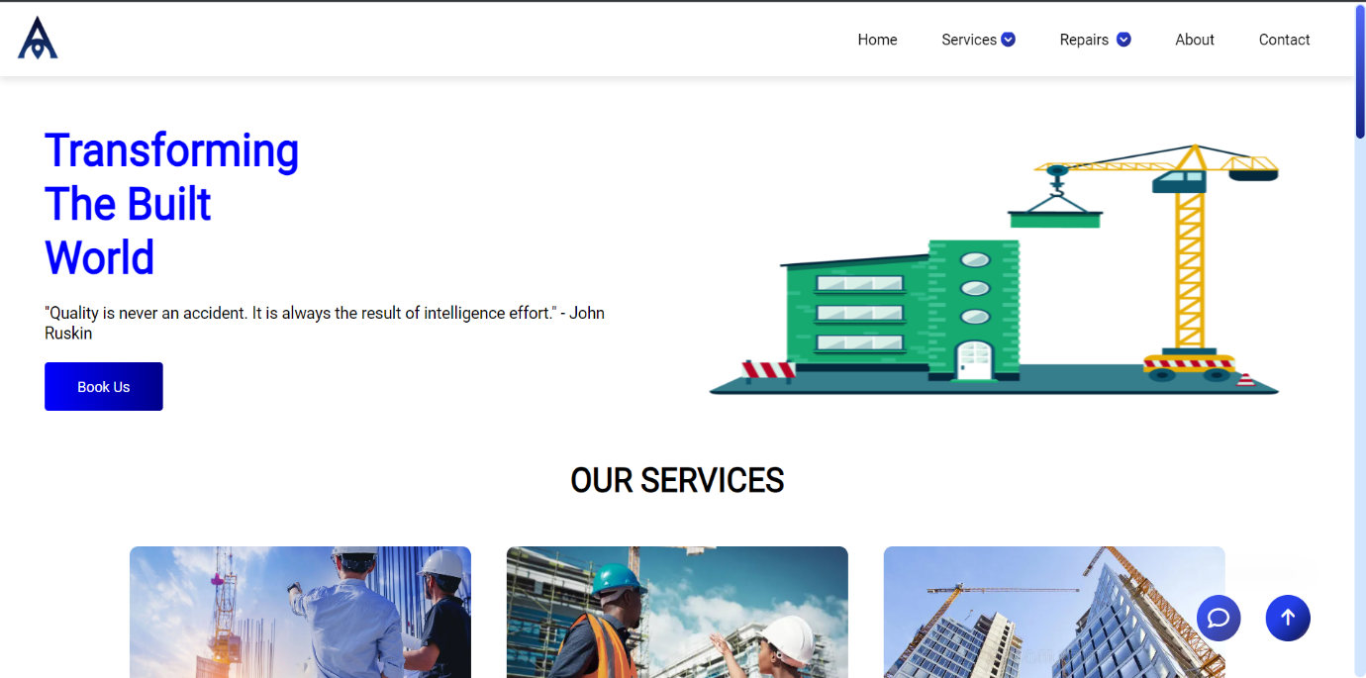

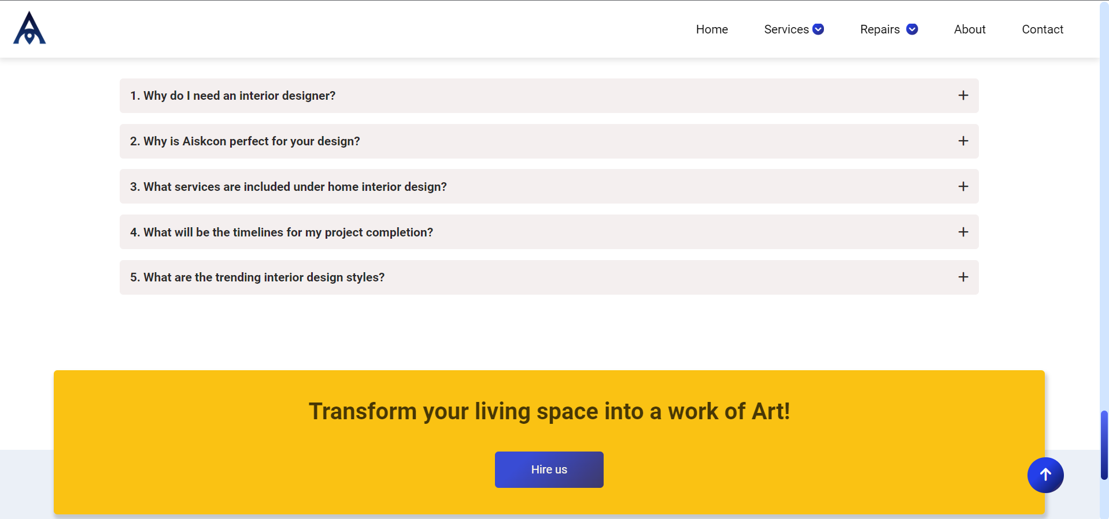

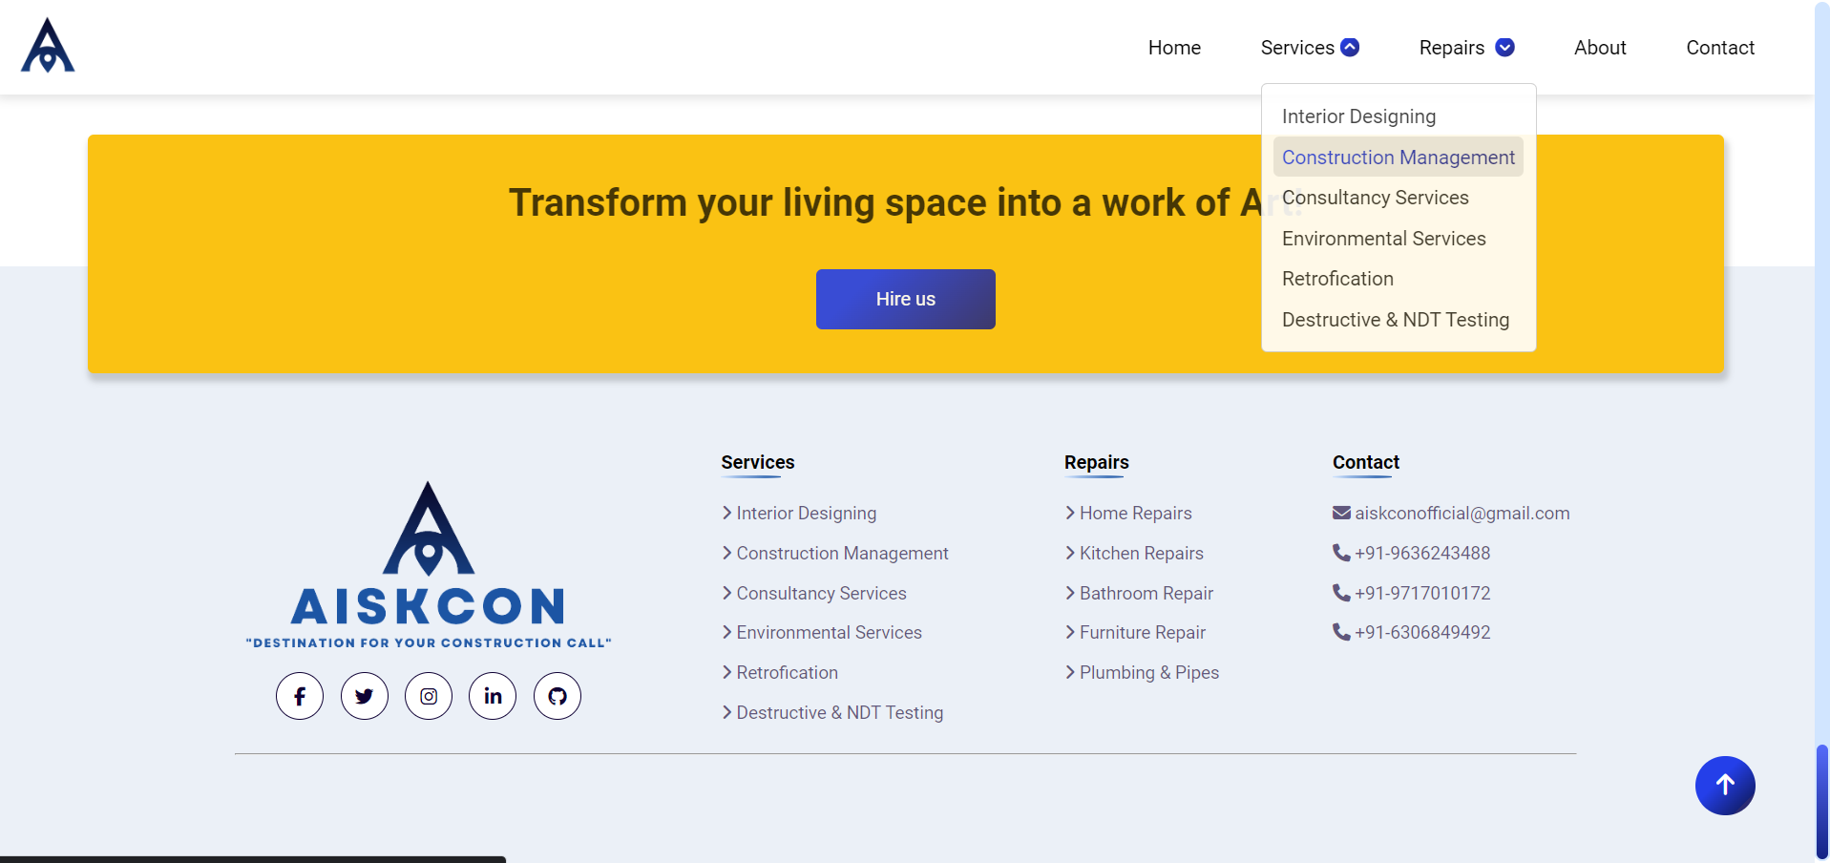

**ii. Login Page:**

This is the page where an existing user can log in and view all the features of the website.

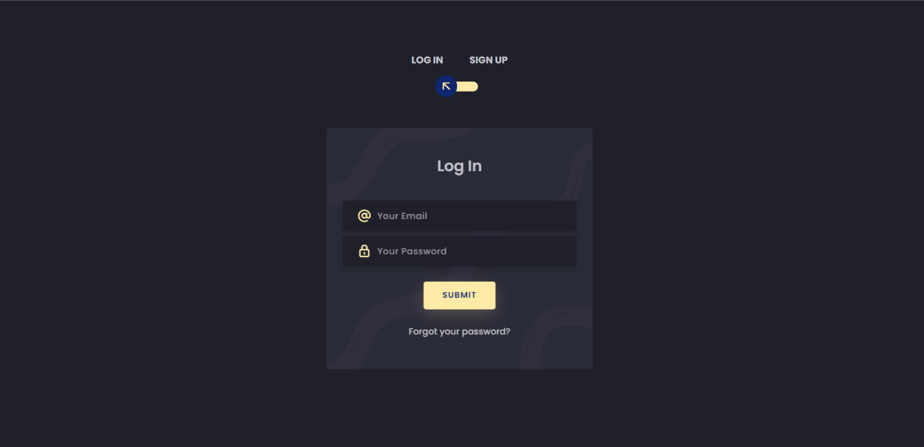

**iii. Sign up Page:**

If a user is new to the webpage, they can register here and get information about any new information that we post and receive newsletters via mail.

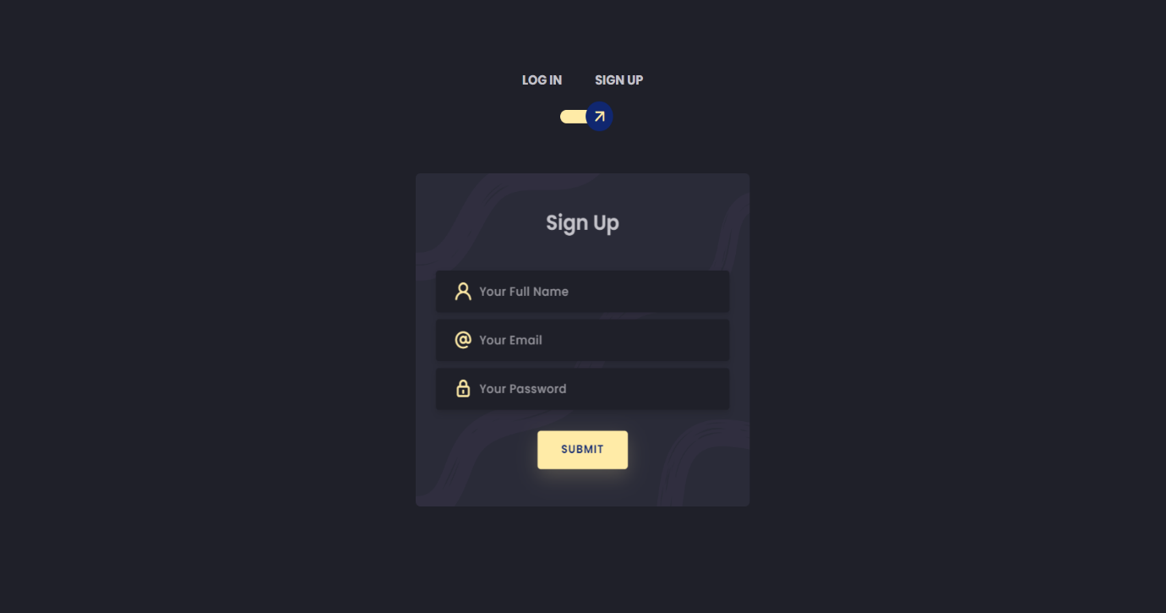

**iv. Services Page:**

This is the webpage where the user can look after the services provided by the comstruction company.

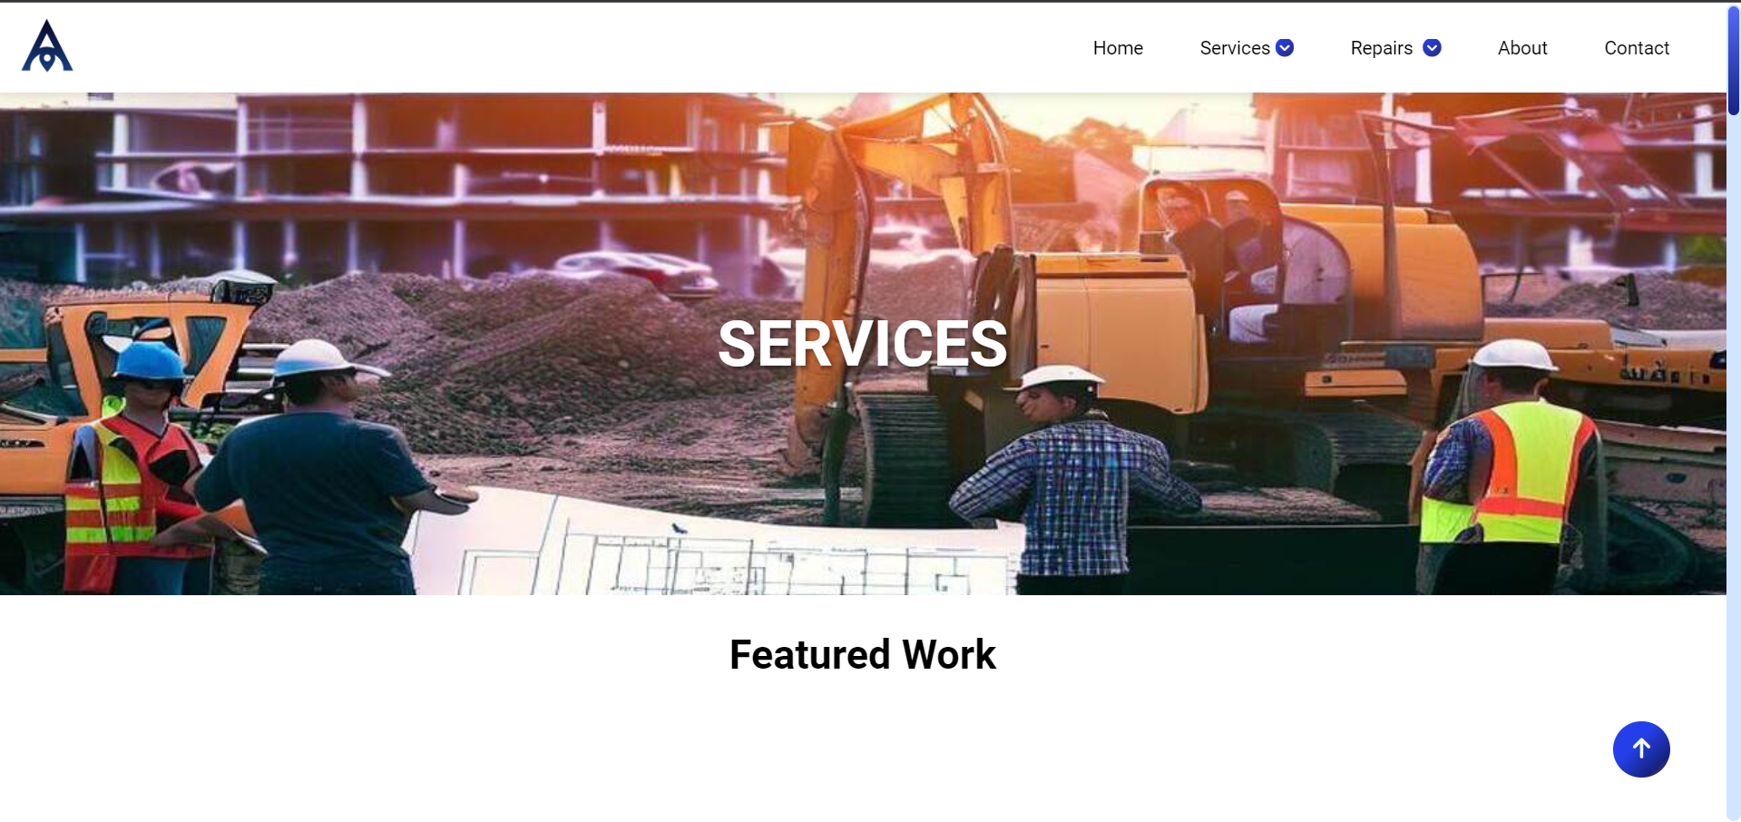

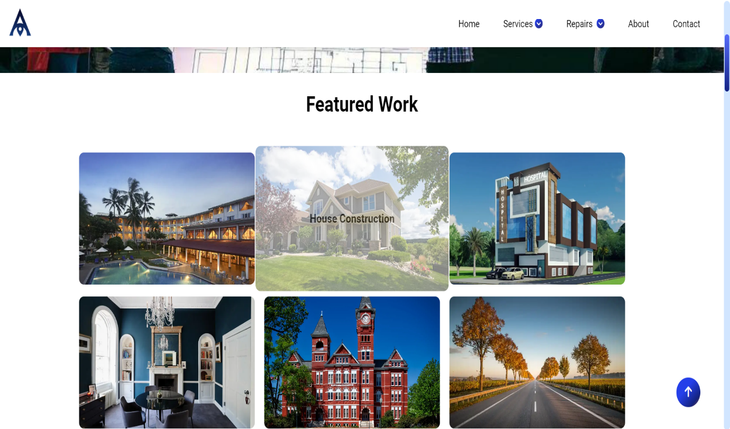

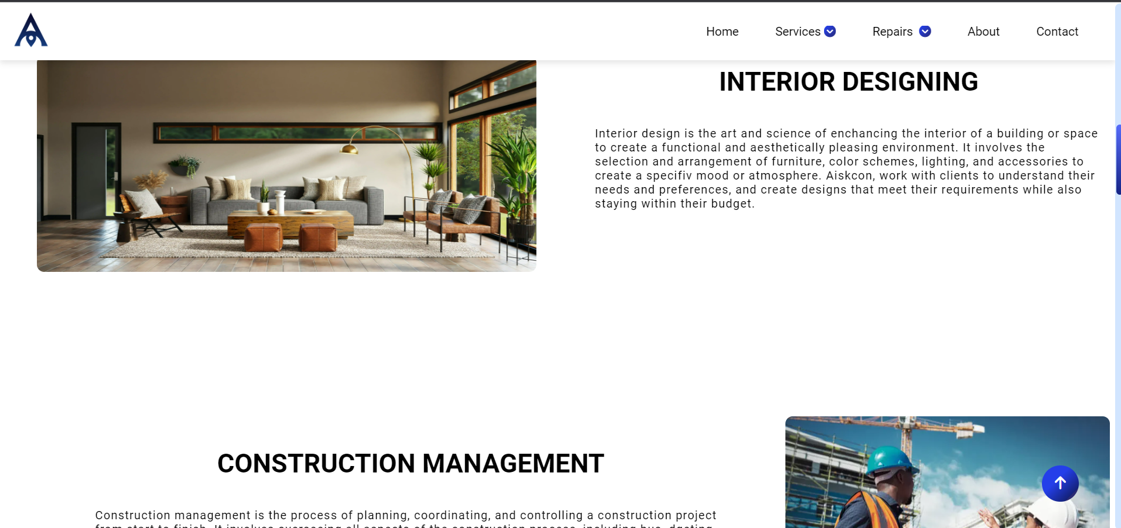



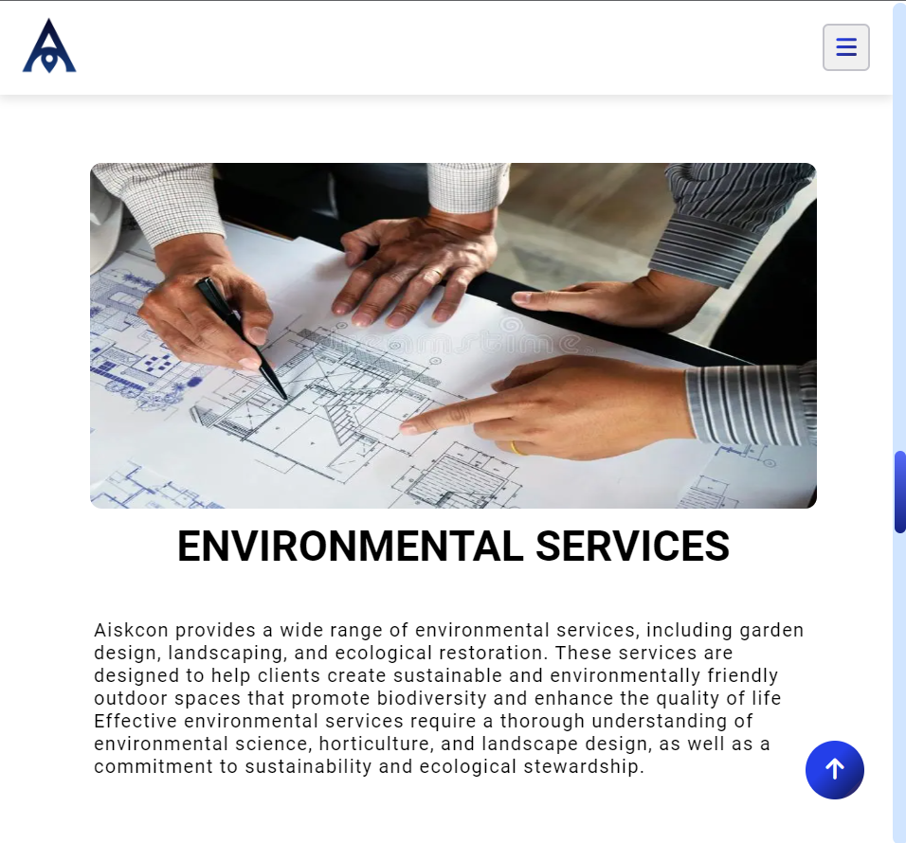

**v. Repairs Page**

This is the webpage where the user can look after the repairs which was provided by the construction company.

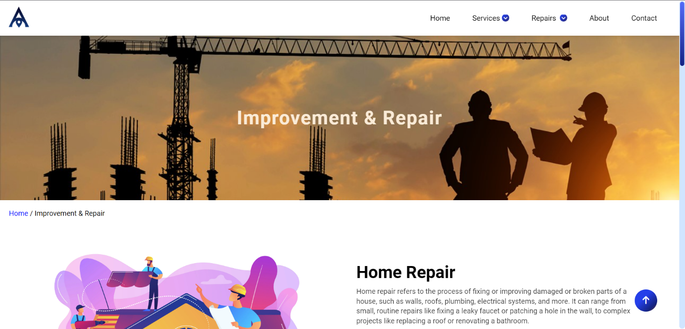

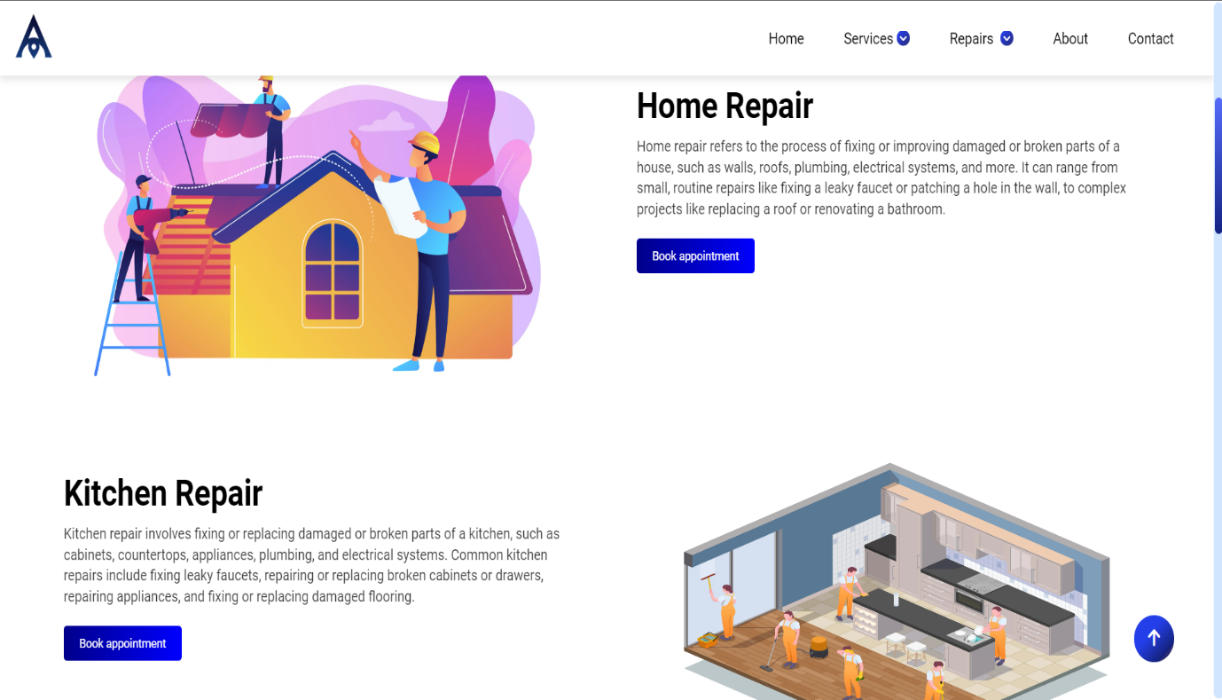

**vi. Contact Us Page:**

This is the webpage where the user can contact us, if they have any queries regarding anything in our website and leave a message for us.

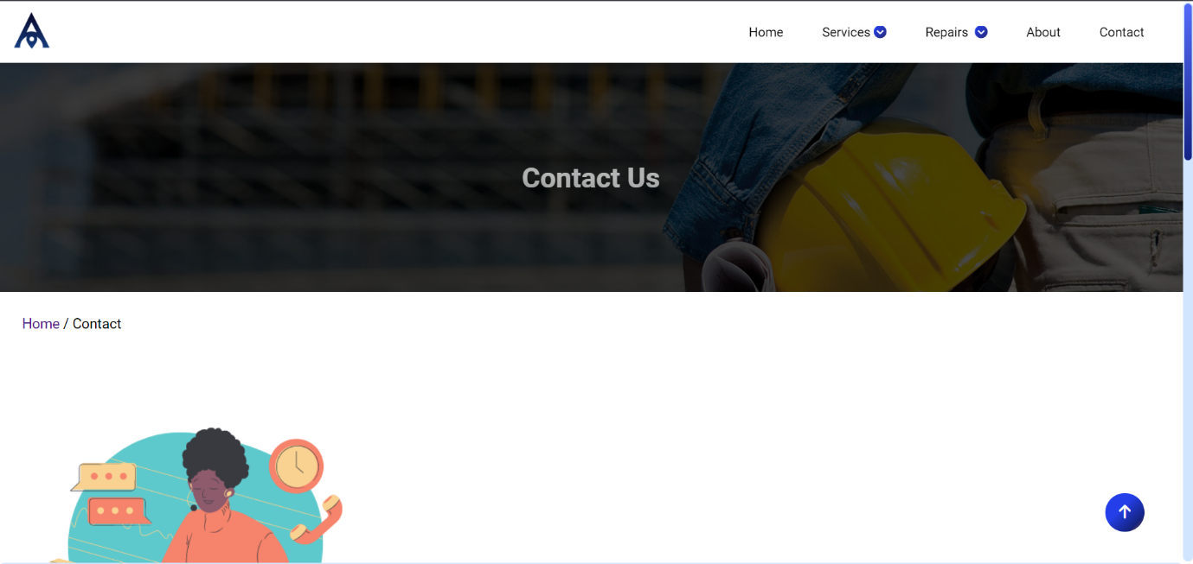

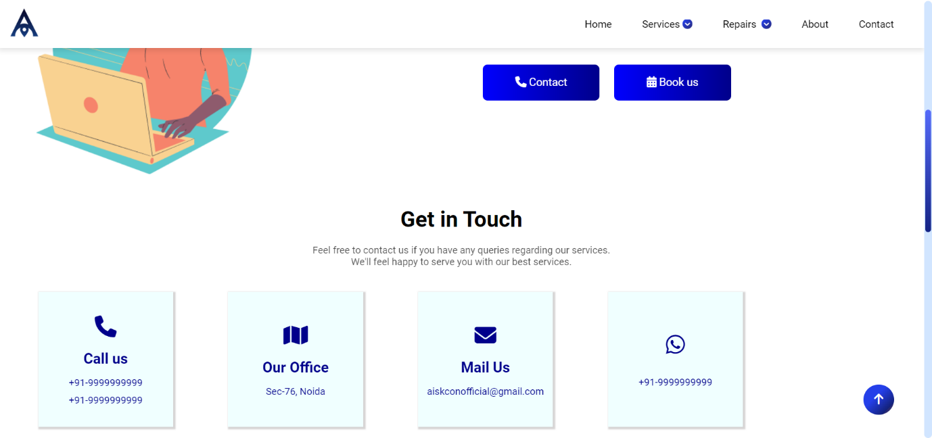

**vii. About Us Page:**

This is the webpage that tells the user about the company which provides these services and repairs.

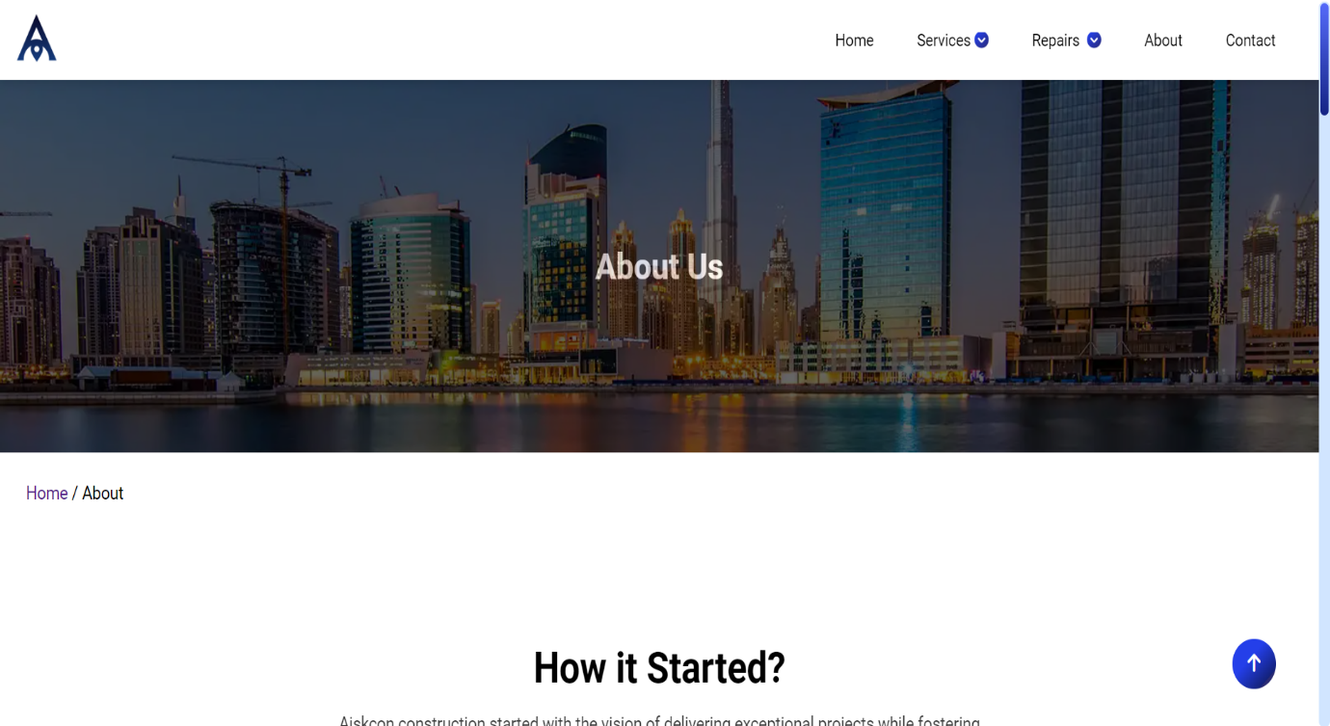

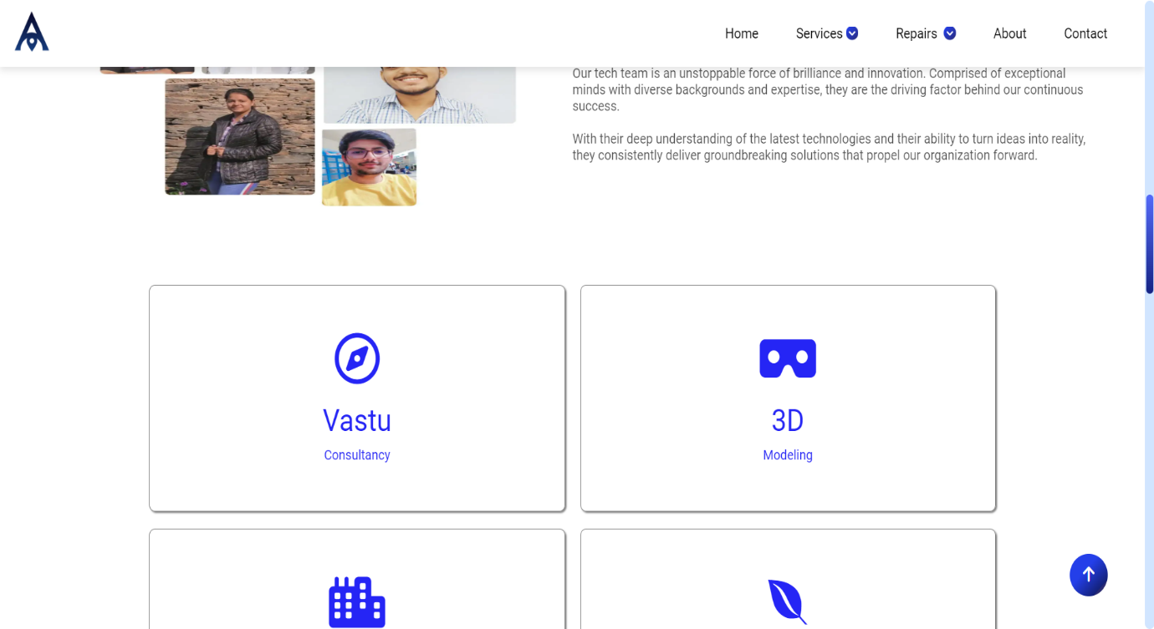

**viii. Book Appointment Page:**

In this page the user can book the appointment for which services or repairs the user want. The user has to give the full details of information.

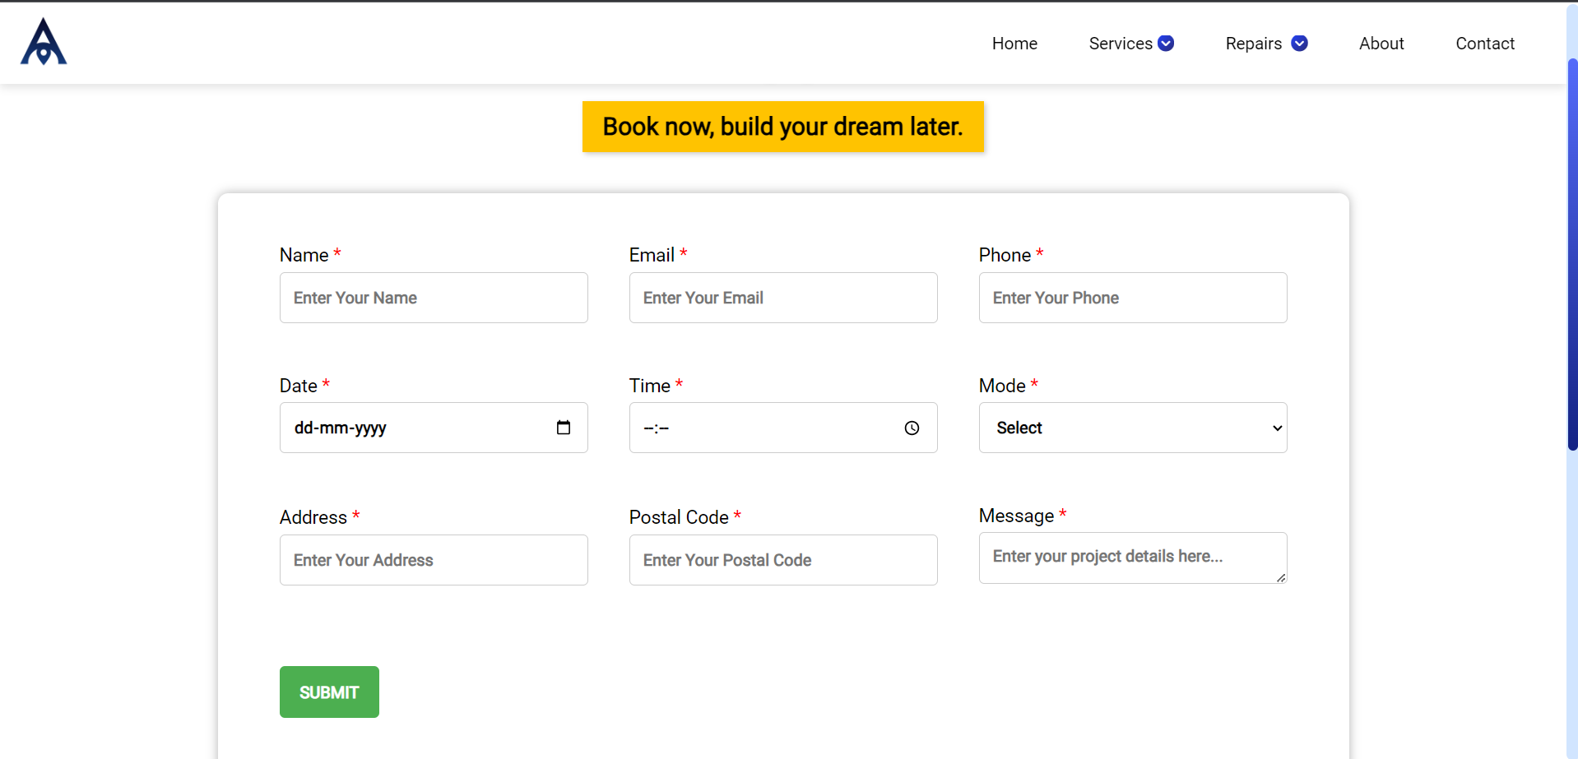

**CHAPTER – 7**

**CONCLUSION AND FUTURE WORK**

**7.1 Conclusion:**

The website built using front-end technologies, showcasing constructions in India segregated by Aisken Constructions, provides an informative and interactive platform for users to explore and book their construction and repairs appointment. With its intuitive design, comprehensive information, and interactive features, the website offers an engaging and user-friendly experience, promoting constructions and repairs across various states in India.

**7.2 Future Work:**

This project offers several opportunities for future work and enhancements. Potential areas for future work include expanding the content by regularly updating and adding more services, repairs for construction information. Integrating multimedia elements like high-quality images, and interactive details can enhance user engagement. Implementing user-generated content features such as reviews and ratings can foster a sense of community. Developing a mobile application version of the website can cater to users preferring mobile devices. Integration with social media platforms and multilingual support can increase reach and accessibility. Advanced search and filtering options, personalized recommendations, and integration with booking systems can enhance user experience and generate revenue opportunities. Ongoing performance optimization, analyzing analytics, and staying updated with industry trends are crucial for continuous improvement.